

**NextIntern**: **Personalised Internship Search Platform**

Dissertation

CO3015 Computer Science Project

University of Leicester Department of Informatics

Ayomide Balogun - 229062975

Submitted: 02/05/2025

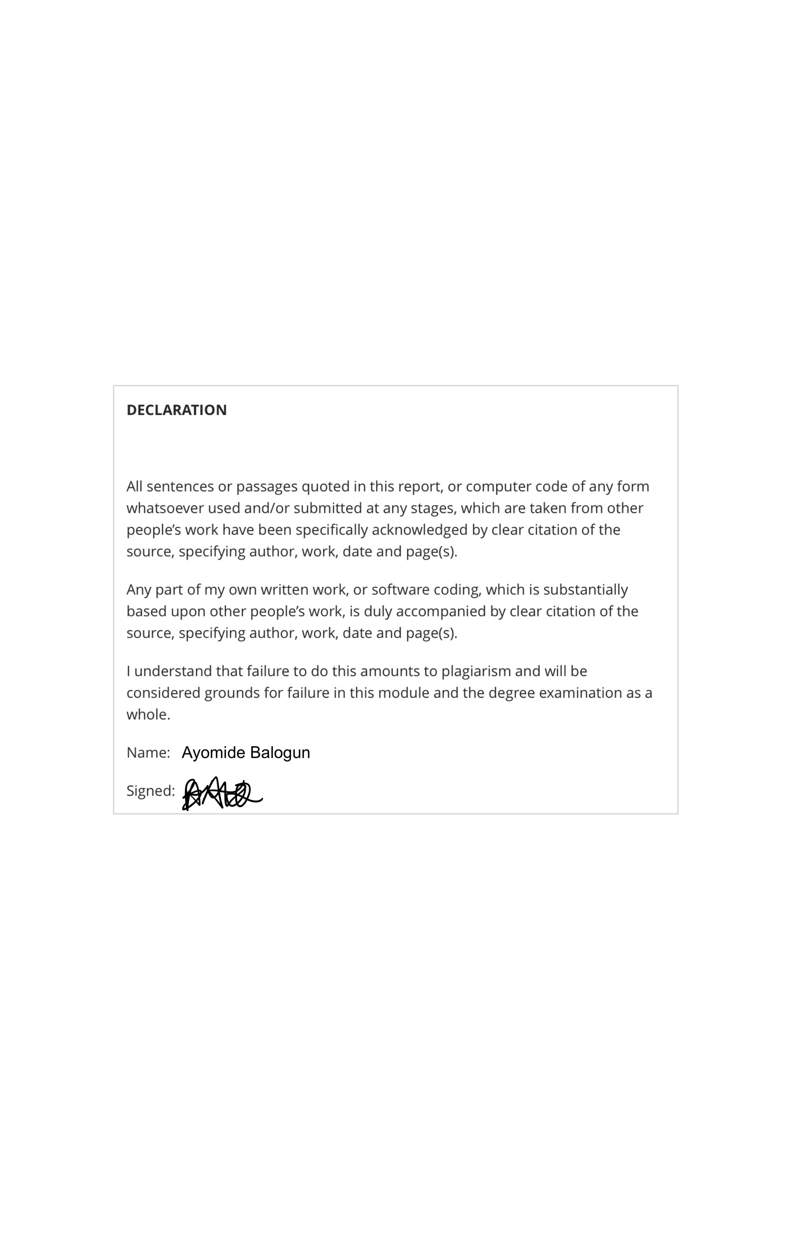

Contents

Contents 2

1 Abstract 4

2 Introduction 5

2.1 Context 5

2.2 Motivation 6

2.3 Aims 7

2.4 Objectives 7

2.5 Solution Overview 7

2.6 Roadmap 8

3 Literature Review / Background 9

3.1 Surveying the field 9

3.2 Comparative Analysis 15

3.3 A Reflective Account 17

4 Design 17

4.1 System Architecture Overview 17

4.1.1 Application Features 17

4.1.2 **Client Layer (Frontend Layer)** 17

4.1.3 **Application Layer (Backend)** 18

4.2 Key Components & Interactions 20

4.2.1 **Frontend Components** 20

**4.2.3 Firebase Services** 22

4.3 Data Flow and Database Design 22

4.4 Alternative Considerations 25

4.5 Security 26

4.6 Scalability 27

4.7 Usability 28

**4.7.1 Responsive Design** 28

**4.7.2 Accessibility** 28

5 Implementation 29

5.1 Development Process 29

5.2 Key Features 30

5.3 Key Resources 30

**5.3.1 spaCy (en_core_web_lg)** 30

**5.3.2 Sentence Transformers (all-MiniLM-L6-v2)** 31

**5.3.3 Pandas DataFrames** 31

**5.3.4 NLTK Stopwords** 32

**5.3.5 Custom Skill Patterns (_initialise_skill_patterns):** 32

**5.3.6 CV Parsing (parse_cv)**: 33

**5.3.7 Match Score Calculation (calculate_match_score)**: 33

5.4 Match Score Implementation (cv_predictor.py) 34

**5.4.1 Category Matching (_find_similar_job_category)** 34

**5.4.2 Reference Resume Selection** 34

**5.4.3 Core Match Score Calculation** 35

5.5 Skill Gap Analyser Implementation (skill_gap_analyser.py) 36

5.6 Flask API Endpoints (app.py) 38

5.7 Technical Challenges 38

**5.7.1 Expo and Node Modules Issues** 38

**5.7.2 Cross-Origin Resource Sharing Challenges** 39

**5.7.4 Cloud Deployment** 40

6 Testing and Evaluation 43

6.1 Unit Testing 43

6.2 Integration Testing 44

6.3 System testing 45

6.4 Reliability and Robustness 45

7 Results and Discussion 45

7.1 Exploring NextIntern 45

7.2 Analysis 49

7.3 Comparison to Literature 50

7.4 Implications 51

8 Reflection and Conclusions 51

8.1 Critical Self-assessment 51

8.2 Learning and Development 52

8.3 Social, Commercial, and Academic Context 52

8.4 Future improvements 53

8.5 Summary 53

References 54

1. Abstract

NextIntern is a web application designed to help students discover, manage, and track internship, placement, and graduate role applications. The application is specifically designed to recognise law, finance and technology students; these are sectors I identified to which internship and general external experiences are particularly sought after by employers, but equally difficult/tedious to secure. In my own personal experience, I have found that existing software’s have only accentuated the stressfulness of the vigorous internship application process. A lot of current software for applications feature dull user interface, low overall quality, little to no internal support for tracking or matching and usually unorganised in terms of filtering (extending the efforts required to find what you are looking for). Conversations with peers confirmed that these frustrations are widespread.

On my pursuit to solve this issue, I investigated the problem space, and the core pain points in the current application process and current application software. By critically analysing existing tools, I was able to identify overlooked factors such as location emphasis and the lack of matching tools. My final approach prioritised the idea of a user-centred design with the impact of advanced technology during an internship search. I implemented a location-based filtering system, a machine learning based matching tool to boost suitability awareness (and therefore student confidence), and a skill gap analysis feature to provide actionable feedback so students can attain specific aims. The development process involved overcoming significant technical challenges, including cross origin sharing challenges whilst integrating APIs, CV extraction issues, a considerable cloud deployment attempt and more.

Nonetheless, results include a responsive and well-structured web application that streamlines the application process, offers tailored opportunity recommendations, and provides students with clear, actionable steps to improve their chances of secured desired internships, placements or graduate roles. The most important implication for me is the platform’s potential to make a hidden but definite improvement in students’ chances of securing roles which ultimately restores faith in the application process and supports equal access for all students (in the three domains) to paid opportunities.

2 Introduction

2.1 Context

The process of securing internships, placements, and graduate roles is a common challenge for students in technology, finance, and law. These fields are not only highly competitive (in terms of student expectations by the employers), but also saturated with internship applicants. For example, some roles will feature hundreds of applications from competent and talented students, however the company may only be accepting 10 interns. Nonetheless, students in the fields of technology, finance and law are forced to still embark on the journey of securing an internship. This is because the high saturation in the industry and trust that early work experience gives to employers, makes early work experience (internships etc) one of the best ways to stand out and break into the industry (from student to professional).

Existing digital tools available to support students in this journey are, in my experience and that of my peers, fundamentally lacking. They are often uninspiring, difficult to navigate, and fail to provide the tailored support that students deserve. Instead of empowering users, these platforms can reinforce feelings of intimidation and confusion, especially during the high-pressure ‘application season’. Many sites present overwhelming amounts of raw information, poorly filtered and rarely personalised. Key factors such as location, personalised opportunity (closely suiting the user) are often ignored. Ultimately, students are left to navigate a sea of opportunities with little guidance or support.

2.2 Motivation

I posed this project idea as my own curated idea, my motivation for this project is personal. As a student who has been through the process of actively seeking internships in the technology sector (especially during my second-year), I experienced first-hand the frustration of using platforms that unconsciously made the process harder [3,4]. Location information was often poorly highlighted, many opportunities were inactive or outdated (especially for the sites that were actually good, but opportunities were inputted manually creating a bottleneck in attaining opportunities), and the user interfaces were so uninspiring that the process felt monotonous and demotivating [4]. The majority of application sites lacked any internal tracking or management features to ‘save’ opportunities, forcing me to rely on an external spreadsheet or screenshotting, to save desired opportunities. I discovered that many sites would even just prompt you to subscribe to individual company mailing lists, which could ultimately lead to you getting even more lost in the sauce of applications or to you receiving irrelevant company information. This not only makes the process more tedious but also increased the risk of missing out on valuable opportunities.

Research amongst peers revealed that I was not alone in these frustrations. The sense of walking blindly through the application process, with little direction or support, was a common theme. Many students felt overwhelmed by the volume of information and underwhelmed by the quality of the tools available to help them. The collective experience highlighted a clear gap in the market: the need for a platform that not only simplifies the process but also actively supports students in finding and securing relevant opportunities.

Looking positively at past internship application processes, I found that there are a vast number of charities and sponsors of educational opportunities open to help a plethora of different groups within the field, however many are unaware of these organisations. It was important to me that I highlight these particular organisations on my platform, encouraging further outreach and support to all that are unaware of the many resources available to them.

2.3 Aims

The primary aim of this project is to streamline and enhance the internship and placement application process for students in technology, finance, and law by leveraging advanced technology and a user-centred design. The goal is to create a platform that makes the process less tedious, more effective, and increases success for students looking for an internship, placement or graduate role. The project seeks to restore faith in the application process by providing tools that empower students to take control of their career journeys, rather than leaving them to navigate a confusing and discouraging landscape.

2.4 Objectives

* Create a comprehensive feature list based on user needs and market gaps, ensuring that every aspect of the platform addresses an existing issue.
* Develop detailed user stories and task lists to guide the implementation of these features.
* Build an integrated map system with location-based filtering, allowing students to discover opportunities relevant to their preferred locations and commute options.
* Implement a machine-learning based matching tool that analyses student profiles and opportunity requirements, providing a suitability score and boosting application confidence.
* Develop a AI-powered skill gap analysis feature that offers personalised recommendations for courses, projects, and experiences to enhance employability and chances of securing desired roles.
* Design a user interface that is both friendly and engaging, reducing stress and making the application process enjoyable.
* Gather and incorporate feedback from students during testing to ensure the platform genuinely improves the application process and meets user needs.

2.5 Solution Overview

To address shortcomings and lack of support in existing internship application software I have designed and developed NextIntern, a web application that puts the needs of students at the centre.

These are the key features I included to solve overlooked elements in existing software:

* Location-based filtering using Google Maps API, allowing students to discover opportunities relevant to their preferred locations and commute options.
* Machine-learning based matching that analyses student profiles and opportunity requirements, providing a suitability score (not just using keyword matching but using domain knowledge). This works to boost application confidence.
* AI-powered skill gap analyser that offers personalised recommendations for courses, projects, and experiences to enhance employability for specific opportunities.
* Intuitive user interface designed to reduce stress and make the application process engaging.
* Promotion of charities and sponsors of educational opportunities open to help a plethora of different groups within the fields

The development process was guided by a commitment to user-centred design and feedback. I conducted research into existing tools, identified overlooked factors, and incorporated advanced technology to make the application process more effective and less stressful. The result is a platform that not only simplifies the process but also makes a definite improvement in students’ chances of securing roles.

2.6 Roadmap

This dissertation is structured as follows:

|  |  |
| --- | --- |
| **Abstract** | A concise summary of the project, approach, and key results. |
| **Introduction** | Context behind the project, motivation, aims, objectives and solution overview. |
| **Literature Review/Background** | Critical analysis of existing platforms, research behind technologies used, theories and highlighting the project’s uniqueness. |
| **Design** | System architecture, key components, design decisions, and considerations for security, scalability, and usability. |
| **Implementation** | Development process, core feature highlights, technical challenges, and integration strategies. |
| **Testing and Evaluation** | Testing methods including unit testing, API testing using Postman and evaluating user feedback. |
| **Results and Discussion** | Analysis of results, comparison to objectives and literature, implications, and limitations. |
| **Reflection and Conclusions** | Self-assessment, learning outcomes, and future improvements. Also, a holistic summary of achievements and considerations for further development. |
| **References** | Comprehensive citation of all sources used. |

3 Literature Review / Background

3.1 Surveying the field

There are currently several notable tools and websites designed to help students find opportunities. However, I have noticed limitations from each that my project aims to address.

**Bristol Tracker (recently updated to ‘Trackr’)** is a personally favourable internship application solution, especially due to it being student tailored. It combines internship opportunities, particularly in finance, law, and technology, into a single interface that tracks application deadlines, links program information and provides overlooked but important and helpful detailing such as whether an opportunity requires a cover letter or not. During my research, I noticed that a few other existing charities and platforms have similarly honed in on my chosen sectors, assumingly due to the same reasons. Previous social media content confirmed that the opportunities listed on Bristol Tracker are manual. Other confirmations include the combination of the spreadsheet formatting, evaluation of site patterns and slot at the bottom of page prompting users to provide any opportunities visibly missing. I assess ‘manual entries’ to be an application bottleneck; it limits the number of active listings and causing irregular updates. For instance, during my research, I observed significant gaps in opportunity listings (*Figure 1*), with extended periods where no new roles were posted, despite certainty in ongoing internship recruitment and releases in real-time during those periods (and till now). This was further confirmed through sources like LinkedIn and company websites that still managed to post opportunities regularly during Bristol Tracker’s inactive periods.

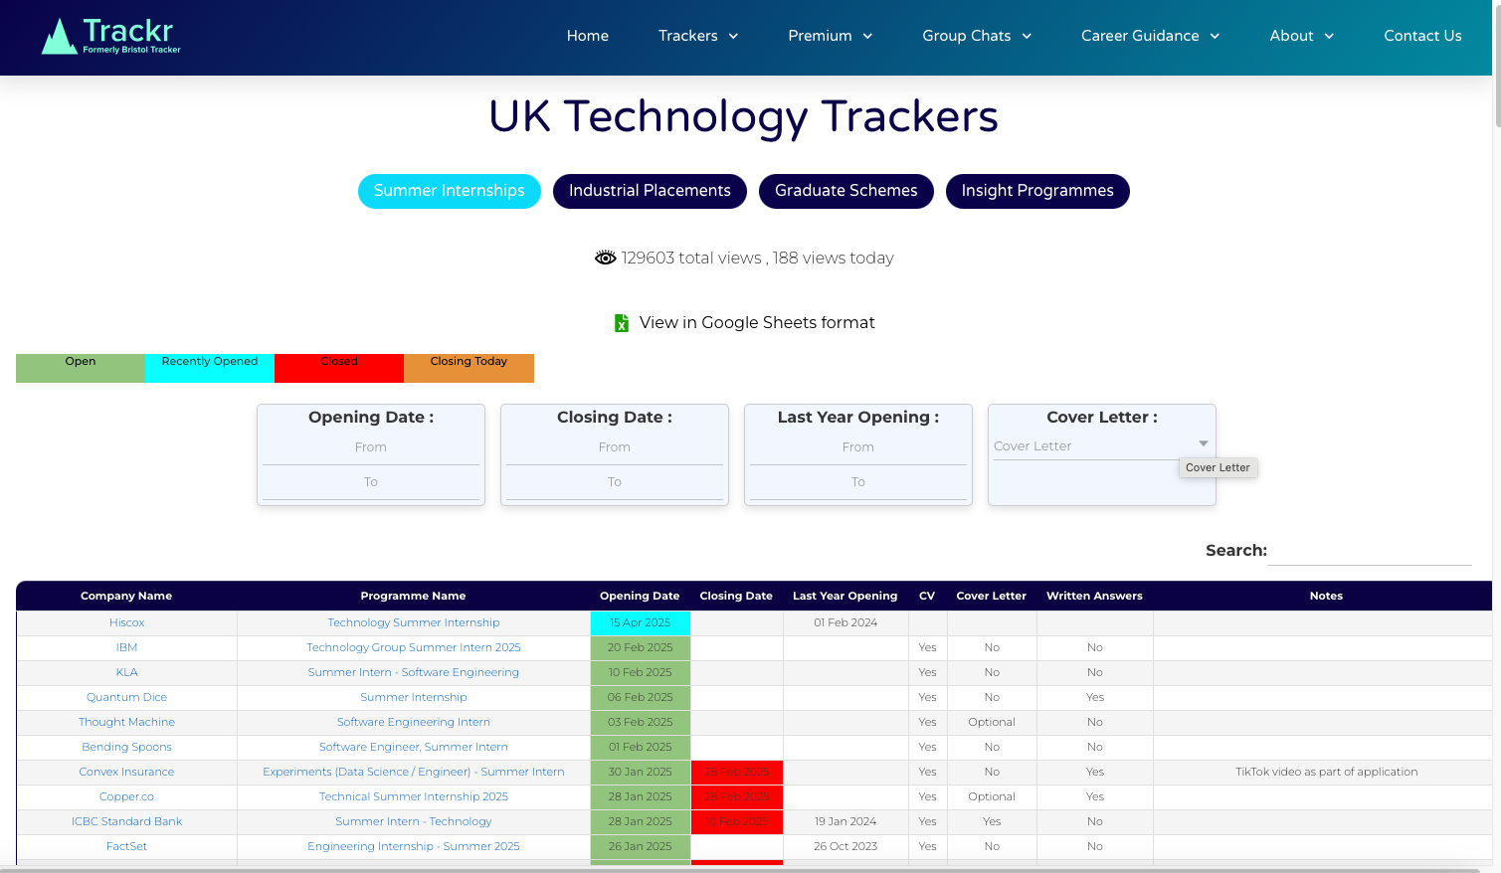

*Figure 1: Bristol tracker featuring upload gap (from February to April).*

To counter this issue within my own application, I integrated an API from a job listing site Adzuna, which offers thousands of active listings across the UK and promises continuous updates, eliminating reliance on manual input. While web scraping could have been an alternative, I decided to prioritise GDPR compliance and avoid potential legal issues with sites I initially considered web scraping for job listing data like LinkedIn and Glassdoor. This is backed by my aim for my software to be of ‘industry standard’. Linkedin and Glassdoor particularly, do prohibit scraping and their API’s are closely reserved and protected for inner members (requiring direct contact to attain and could cost me). I understand that it is legal to web scrape, but many of these other job listing sites reserve the right to block your IP if they deem you to be web scraping excessively or to be scraping something behind a wall (. e.g. You would normally need to log in to retain that info). To avoid this unreliability in my site I opted to use something more reliable – Adzuna API.

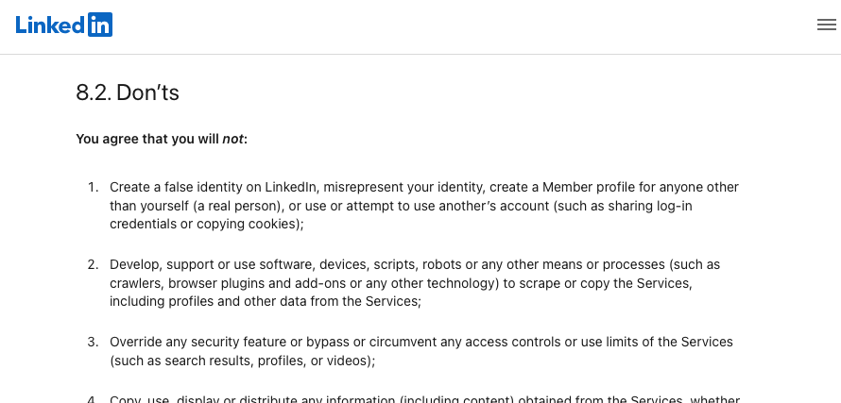

*Figure 2: Linkedin’s clear prohibiting of web scraping via their user agreement.*

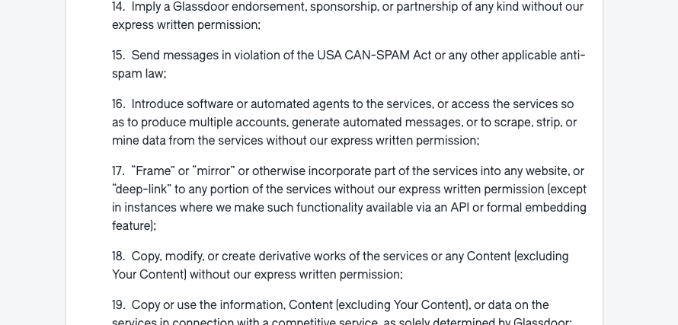

*Figure 3: Glassdoor’s clear prohibiting of web scraping via their terms of use.*

Sanctuary Graduates is another platform that presents a list of graduate/internship opportunities. However, its limited job listings (evident in *figure 4*) restricts its usefulness for students seeking diverse options. Although the UI is not too overwhelming, and therefore the site is easy to navigate, there is a severe lack of tools including no option to save liked opportunities. Additionally, I found that the site is also unresponsive/has responsiveness issues; I was unable to view all opportunities until expanding my screen.   
  
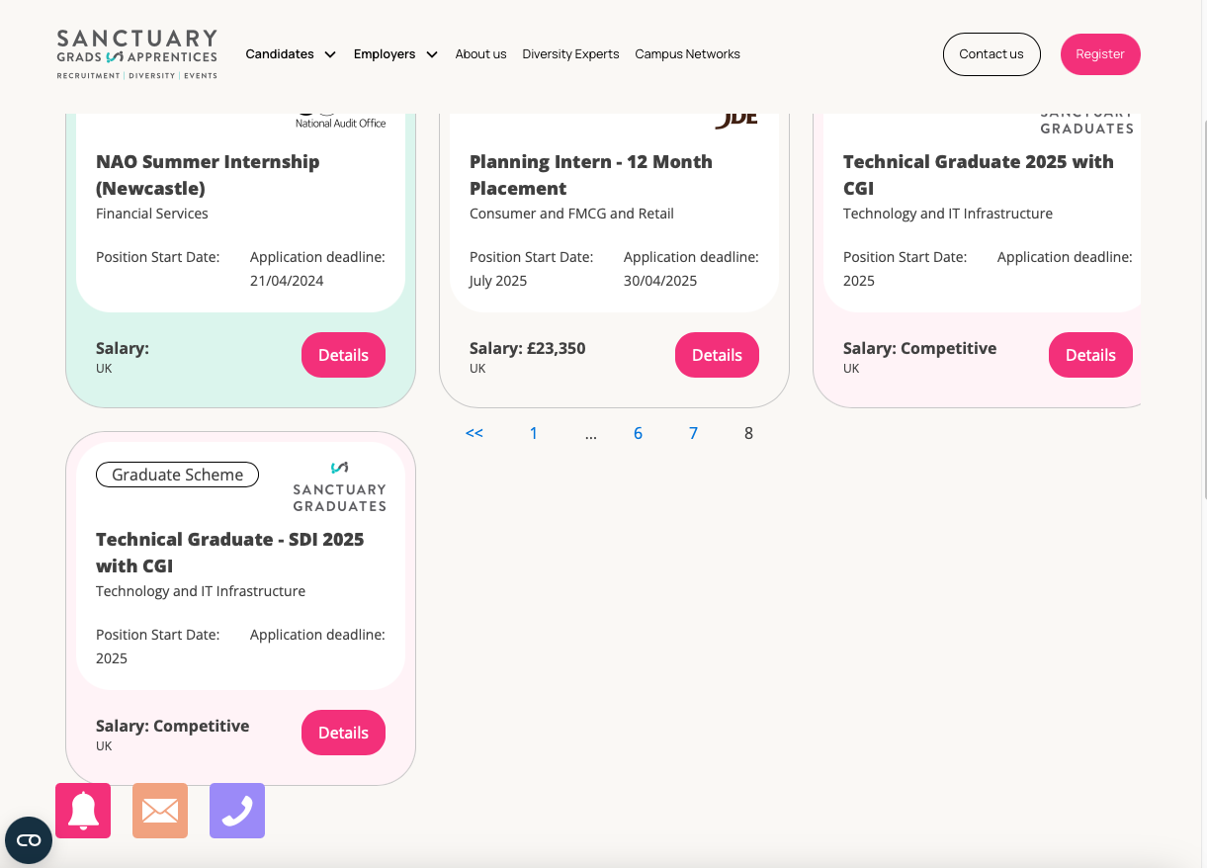

*Figure 4: Sanctuary Graduate’s Job Board.*

LinkedIn stands out as a professional social network with a robust job and internship listing system. LinkedIn is the only platform I have discovered to attempt a matching system for internship/placement opportunities. LinkedIn’s matching system allows employers to attach desired skills to the job profile/description. LinkedIn then encourages individual users to add ‘skills’ to their own main profile. If the skills of the job listed match the skills of the person on LinkedIn, a skill rating/count is made (*figure 5*). Although this may be a form of match scoring (or skill matching). I believe it to be very surface level and therefore not very helpful for student development and improvement. Many students remedy low counts for desired opportunities by simply adding the missing skills to their profile. This is without seeking relevant changes and implementations that would mean they actually possess these new skills and can evidence it to an employer. Others move forward knowing they do not attain the relevant skills but also having no clue what steps to take to attain them.

To improve upon this, I incorporated a system that acknowledges the user personally with a holistic profile system. My system allows users to upload CVs and enables a machine learning-based matching system using NLP techniques better context understanding whilst evaluating a user against an opportunity.

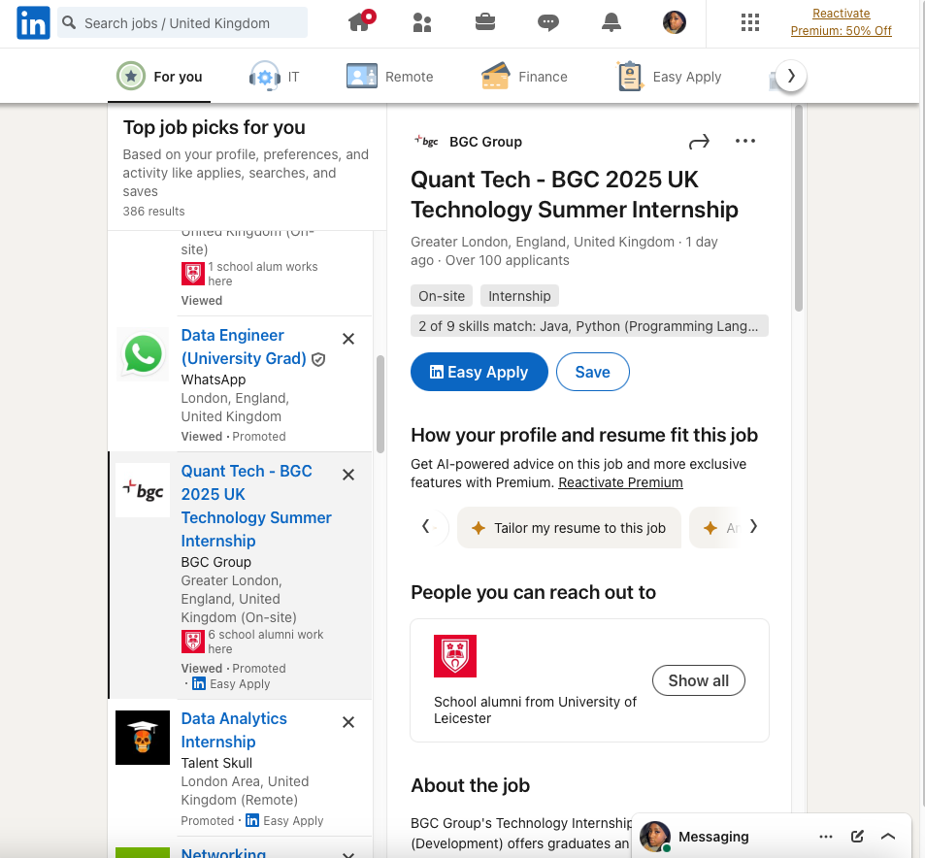

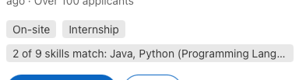

*Figure 5: LinkedIn’s skill matching count*

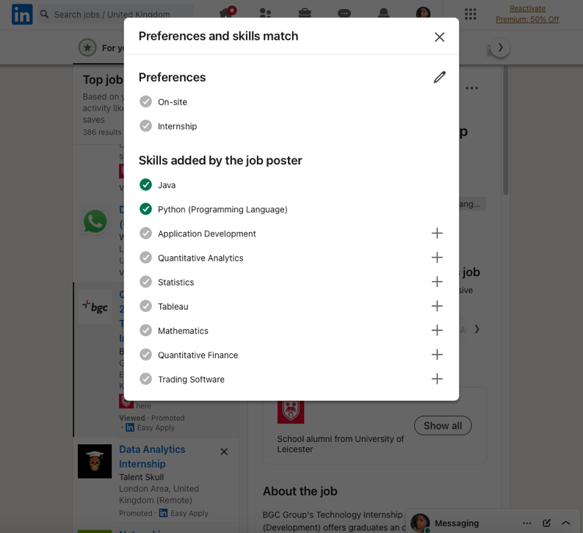

*Figure 6: More insight into LinkedIn’s match scoring system*

RateMyPlacement is noticeably popular amongst UK students. However, the user-interface can be seen as overwhelming and features too many sections, exhibiting information overload. RateMyPlacement lacks advanced features and therefore is not the best for finding user suited roles. Alternatively, a recent feature they have implemented (since their site has improved from the dullness of my application season 2 years ago) is the insights section into the personal journey of other students like myself.

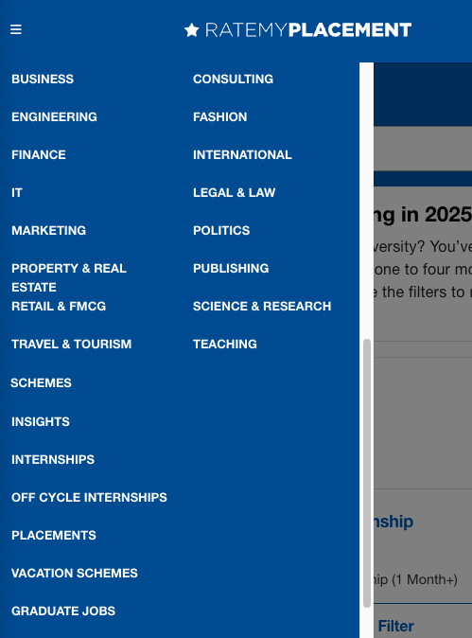 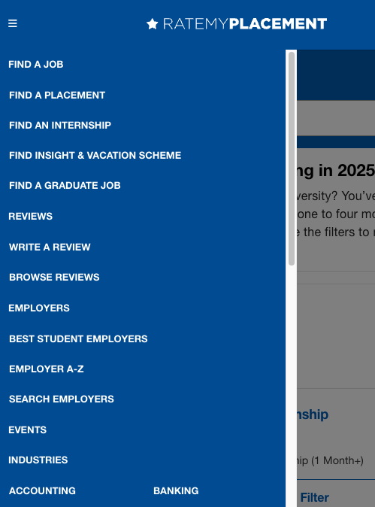

*Figure 7: RateMyPlacement Sidebar featuring navigations overload*

Gradcracker offers a good range of STEM-focused opportunities but suffers from a cluttered UI with information overload (too much wording at once) and ads that can overshadow more relevant roles (to the user). Additionally, their focus on larger companies can sometimes overshadow smaller, more suitable opportunities for students seeking tailored placement opportunities. Finally, I believe there is risk in the ‘follow this employer’ feature as it could lead to students receiving irrelevant company information outside internships, which could add to the stress and clutter of application season.

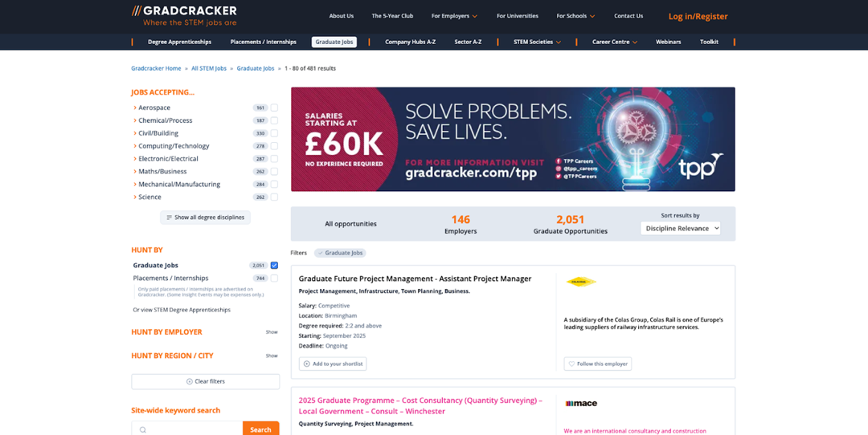

*Figure 8: Gradcracker layout with potentially overshadowing advertisement.*



*Figure 9: Gradcracker internship platform. Known for prompting users to follow full infrastructure of company due to interest in single role (could be misguiding/overwhelming).*

3.2 Comparative Analysis

My platform, NextIntern, aims to transcend these limitations by integrating features that are currently missing from existing solutions:

* Map-Based Filtering: No existing platform offers detailed, map-based filtering that visualises the distance to opportunities [14,18]. This helps students easily identify roles within feasible commuting distances, acknowledging location as more the meaningful filter it is.

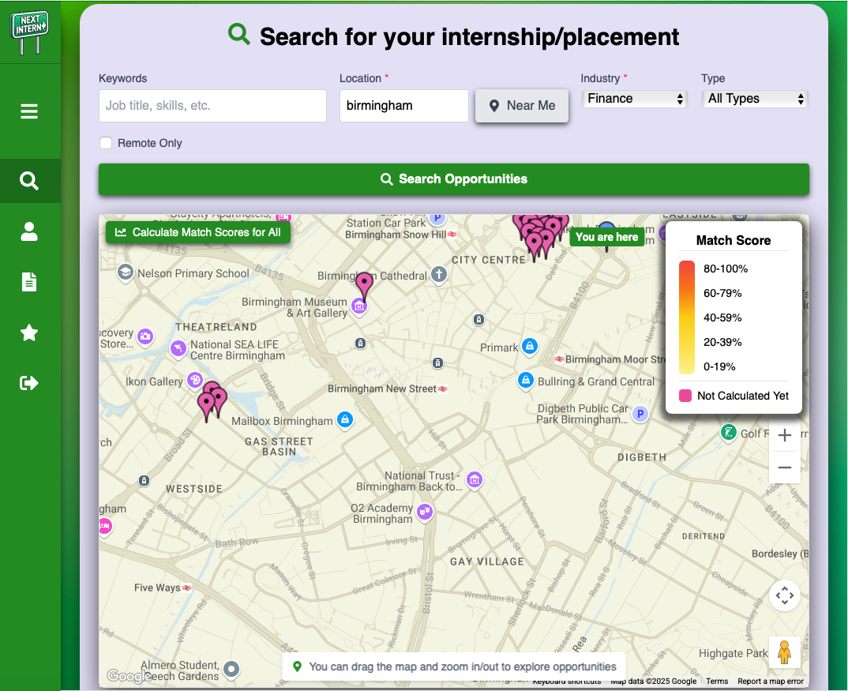

*Figure 10: Map-based filtering on NextIntern*

* Intentional Matching System using Machine-Learning: Unlike surface-level keyword matching, my platform uses advanced NLP techniques and models (such as sentence transformers and spaCy models) to analyse user CVs, profiles, and job descriptions etc, providing a more accurate suitability score percentage. My implementation allows for more accurate, context-aware matching that considers skills, experiences, and aspirations, rather than just keywords.
* Personalised Advice using Artificial-Intelligence: My platform offers tailored suggestions for courses, certifications, and projects based on elements of the user’s profile and specific opportunities they are interested in. This guidance helps students develop relevant skills and improve their chances of success by addressing the lack of depth in current systems that offer other alternate versions of a skill gap analysis.
* A Friendly User-Interface: My interface implements playful, cartoon-style icons, a simple layout and minimal clutter on the sidebar menu; making navigation intuitive and less intimidating for students and generally less overwhelming.

3.3 A Reflective Account

Throughout my research, a key recognition was that effective internship platforms must go beyond listing opportunities; they should provide **contextual, personalised, and visual tools** that empower students and eliminate discouragement. Initial ideas surrounding the project involved simply adapting existing models, but upon critical analysis I realised that intentionally integrating advanced algorithms, map-based filters and tailored guidance could even significantly improve user experience and success rates. This understanding led me to prioritise some of my most impactful features.

I also learned that compliance with data privacy regulations (GDPR) [56] is crucial for my application to be of industry standard with publishing potential. This influenced my decision to avoid web scraping and instead rely on reliable APIs with data partnerships (Adzuna). This ethical approach allows my platform to remain sustainable and trustworthy long-term.

4 Design

4.1 System Architecture Overview

The NextIntern platform utilises a modern, distributed architecture, separating concerns into distinct layers: the client-side frontend (everything happening on the user’s side), application-layer backend services, and cloud-based infrastructure. This approach supports independent development, deployment, and scaling of different system parts.

4.1.1 Application Features

* Authentication
* User onboarding survey and profile management
* Privacy policy
* CV uploading
* Internship search map (detailing opportunities available to you by location, optional filtering included)
* Advanced match scoring for desired opportunities
* Advanced skill gap analysis for desired opportunities
* A saved opportunities section
* Sponsor organisations and charities information

4.1.2 **Client Layer (Frontend Layer)**

* The frontend layer of my application was built with **React, TypeScript and JavaScript.** React is well known as a JavaScript library for building user interfaces. React allows you to build and reuse components seamlessly [5,49,50]. The use of React throughout this project was instrumental in allowing me to achieve a friendly and easy to use frontend design tailored to students. There were quite a few react libraries used throughout my project that proved helpful (such as react-toastify and @vis.gl/react-google-maps).
* I implemented **responsive design** (to the frontend layer) using TailwindCSS and CSS to assure that my web application adapts to a plethora of different window and screen size.
* The frontend layer handles **client-side routing** using React Router (a library for creating dynamic routes and navigation) for client-side routing.
* The frontend layer helps define my application as a **Single Page Application.** This refers to my web application loading a single HTML page and dynamically updating the content as the user interacts with the app, without requiring full page reloads. This allows quick transitions within the software ensures the maintenance of user engagement, amongst other benefits.
* This frontend layer also handles **state management** using React’s state management hooks (useState and useEffect). State management is included also included within other layers of the platform. For example, navigating back to the dashboard from another page or from logging back in, the users google map state and search remains the same.
* This frontend layer manages user interactions and form validations.

Key frontend modules include Authentication, CV Management, User Survey, and Internship Map/Search functionality.

4.1.3 **Application Layer (Backend)**

The application layer contains two main backend services:

* **Express.js Server:**

This acts as the primary API gateway handling core business logic and data flow. This server manages all HTTP requests from the frontend, processes internship search requests, and very importantly, **integrates with multiple services** used on the application. These services include firebase (e.g. for authentication and database), Adzuna API (for job listing results) and the flask API (for my match scoring and skill gap system).

* **Flask API**:

I built my own Python service, using Flask, for CV parsing (using spaCy), skill extraction, match score calculations (with the help of large datasets) and skill gap analysis (using sentence-transformers and OpenAI API). The advanced service was developed in an isolated Python virtual environment (myvenv) to ensure dependency consistency and avoid conflicts with other Python projects. The environment was configured with specific versions of machine learning libraries and NLP tools used. I chose Flask as the framework knowing it would allow me to introduce the python-based predictor and skill gap analyser to the rest of my project seamlessly by building an API[52,53,54].

**4.1.4 Cloud Services & External APIs**

I used cloud infrastructure for scalability and special functionalities:

**Firebase provides** Backend-as-a-Service (BaaS) capabilities, to which I used:

* **Firebase Authentication:** For secure user authentication and management.
* **Firestore:** NoSQL document database for storing user profiles, survey responses, saved internships, current map state and CV metadata.
* **Cloud Storage:** Storing uploaded CV files securely.

**External APIs used:**

**OpenAI API:** Used by the Flask service for the skill gap analysis and semantic understanding.

* + - **Adzuna API:** Integrated via the express.js server to fetch real-time internship listings for the map/search display.
    - **Google Maps JavaScript API:** Used for interactive maps interface that displays opportunities based on location. I used @vis.gl/react-google-maps library as a React wrapper for the Google Maps JavaScript API.
    - **Google Geocoding API:** The geocoding API was also integrated to convert user search locations to map coordinates and display city names from coordinates (using forward and reverse geocoding). The Google Geocoding API is part of the Google Maps Platform and therefore uses the same API key used to enable the Maps JavaScript API.

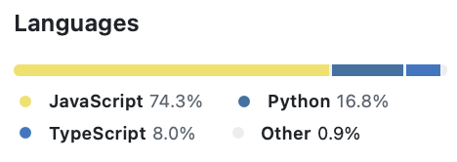

*Figure 11: Language distribution throughout application (as calculated on GitHub)*

4.2 Key Components & Interactions



*Figure 12: UML Class Diagram for Application*

4.2.1 **Frontend Components**

* **InternshipMap:** Manages fetching and displaying internship data. This class interacts with the express backend, which calls Adzuna and Google Maps (including the google geocoding api). This class also handles user filter inputs (when searching for particular opportunities), triggers CV analysis ([handleCVAnalysis] for the match score and skill gap analysis), and allows users to save opportunities seen on the map (handleSaveOpportunity). The map is able to use the CV Predictor (therefore including the cv analysis and the skill gap analysis) through the frontend which makes a HTTP request to the Flask API I created.
* **UserProfile:** Displays user information, manages the survey state (surveyCompleted, editingSurvey), handles survey submission (handleSurveyComplete), and interacts with Firestore (FirestoreDB class

representation) to fetch/update profile data. UserSurvey collects the survey results through the form, and User Profile stores the survey results.

* **CVManagement:** Handles UI for the cv file upload (handleFileUpload), handles deletion of CV from platform (handleDelete) and fetching CV URL (fetchCV). The class interacts with firebase cloud storage which is where the raw cv is stored. So ultimately, I opted for users structured data to be stored in firestore database and for unstructured data to be stored in cloud storage (but all data stored under firebase for optimal integration across the application). The CVManagement class triggers analysis accessibility as a stored CV allows user to access match score and skill gap capabilities.
* **SavedOpportunities:** Fetches saved internships (fetchSavedOpportunities), handles removal (handleRemoveOpportunity), interacts with FirestoreDB directly.
* **UserSurvey:** Manages the survey submission logic (saveSurveyResults), and the display of the survey. The user survey is for new users (can be updated by existing users too through the UserProfile component) and therefore has interactions with UserProfile and FirestoreDB.
* **AuthRoute:** This component protects routes, checking authentication status by interacting with FirebaseAuth (direct firebase integration).
* **MainLayout:** Manages authentication state directly through Firebase Auth. Manages background colour styling and the basic layout structure including expanded/collapsed states for the sidebar.

**4.2.2 Backend Services**

* **CVPredictor (Flask API):** Encapsulates the CV parsing and score matching logic. Uses spacy, SentenceTransformer, and pandas DataFrames (resume_dataset, skills_dataset). Methods include parse_cv for CV text analysis, calculate_match_score for similarity scoring, and skill identification methods (_find_matching_skills, _find_missing_skills) that utilise the cv skills dataset. This class is used directly by the frontend through Flask API endpoints.
* **SkillGapAnalyser (Flask API):** Integrates with OpenAI API (client: OpenAI) to perform skill gap analysis (analyse_gaps) using job details, user profile, and identified missing skills. SkillGapAnalyser constructs intricate prompts (_construct_prompt) and handles OpenAI API responses (_get_openai_recommendations). Works independently of CVPredictor but received missing skills data processed by CVPredictor’s particular skill extraction methods.

**4.2.3 Firebase Services**

* **FirestoreDB:** Represents the interface for interacting with the Firestore database (getting, setting, updating, deleting documents). Used directly by frontend components UserProfile and SavedOpportunities)[51,68].
* **CloudStorage:** Represents the interface for Firebase Cloud Storage operations (uploading, downloading, deleting files). Primarily used by CVManagement for CV file handling.

4.3 Data Flow and Database Design

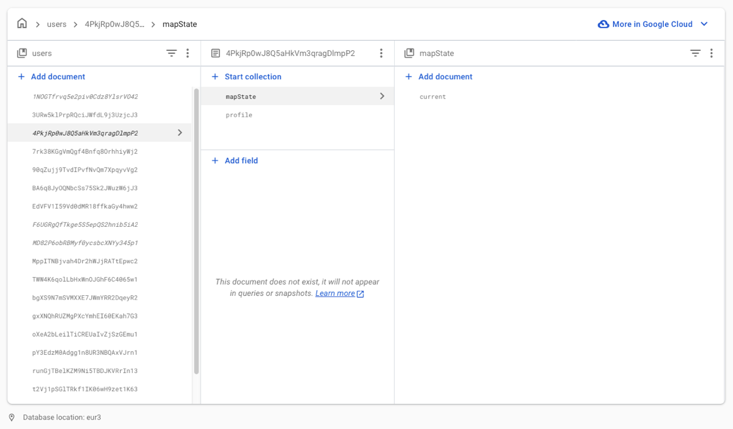

*Figure 13: Application’s Firestore Database*

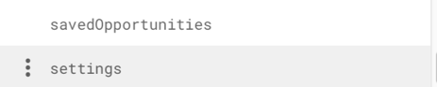

*Figure 14: The other collection available per user*

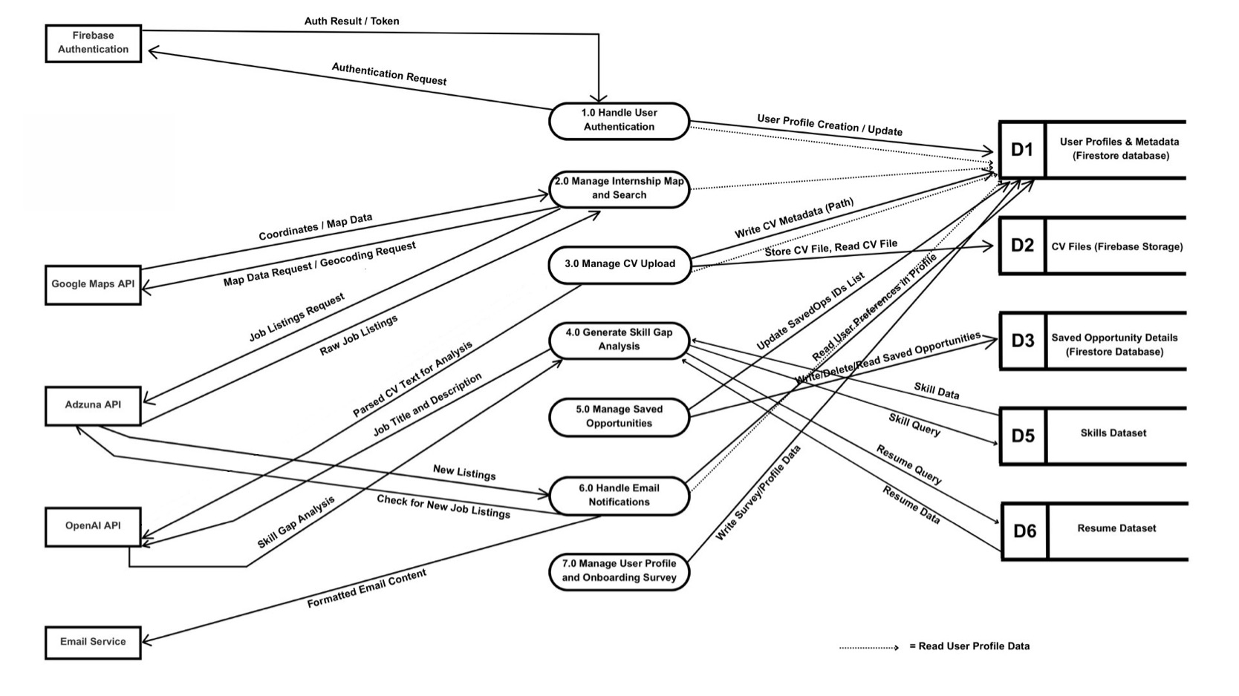

*Figure 14: Data Flow Diagram for Application {email service removed}*

The Data Flow Diagram in *Figure 14* illustrates the primary data flows. It illustrates the movement of data between, external APIs (Google Maps API, Adzuna API, OpenAI API, Firebase Auth), internal processes (1.0 Handle Auth, 2.0 Manage Map, 3.0 Manage CV, etc.), and data stores (DS1: User Profiles, DS2: CV Files, etc.).

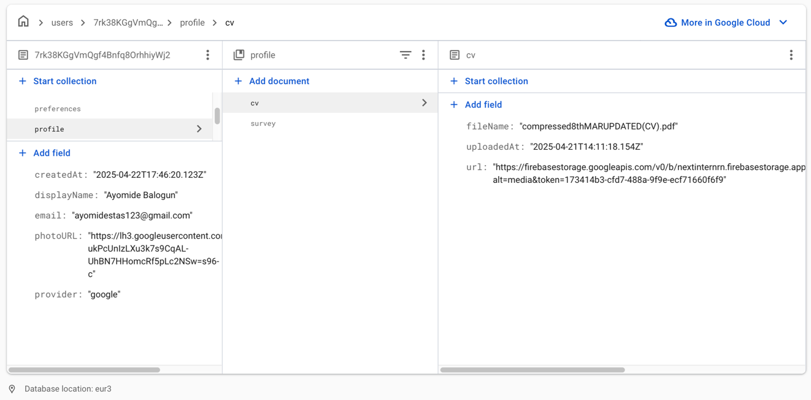

*Figure 15: This image captures an example dataflow that can be traced between process 3.0 and data store 1.*

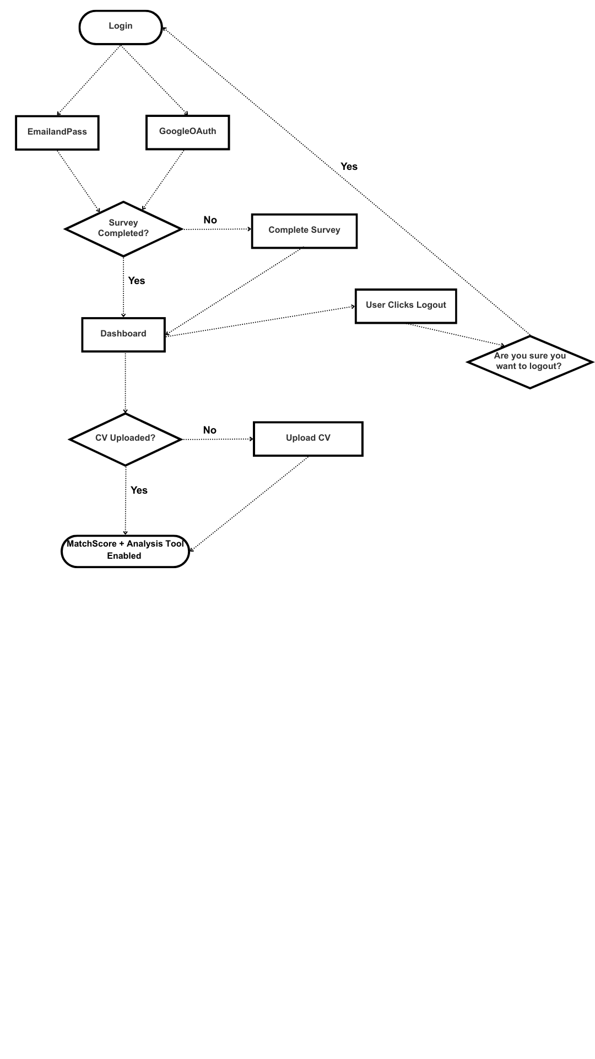

*Figure 16: Flow Diagram illustrating the core user journey from login to feature access.*

The flow chart in *Figure 16* shows the primary user journey with two critical aspects/decisions defining authorised progression into using more of the platforms/more of the platform’s tools. These aspects of the system include:

* Authentication flow with dual login options. I wanted to assure the platform had google login options, OAuth (the underlying protocol that firebase uses) enhances security by allowing users to authenticate with trusted google accounts rather than needing to manage another potentially weak or reused password, increasing security risk.
* Mandatory survey completion (to be able to access main dashboard and therefore other pages).
* Mandatory CV Upload. Without this CV upload the system will decide that it does not have enough background information to perform a match score analysis, and therefore a skill gap analysis.

4.4 Alternative Considerations

During the project several alternative approaches and technologies were considered before arriving at my final architecture and implementation. Considerations were evaluated based on a range of factors such as technical feasibility, time constraints, and alignment with the platform's core goals.

Cross-Platform Development (Flutter/React Native): Initially, I planned on developing the application to be cross-platform by using frameworks such as Dart/Flutter or React Native. The appeal of these frameworks was the cross-platform access across web, iOS, and Android through one single codebase. However, early experimentation revealed that constant platform-specific adjustments throughout would still be necessary to ensure suitable formatting and native feel, particularly concerning UI consistency across different platforms. I ultimately saw this as a limitation considering time constraints and prioritising the core goals of the software itself. As I hesitantly continued with my cross-platform aim, I encountered hurdles related to the emulators for Flutter and the node_modules in React Native. Node_modules is a directory that stores third-party libraries and dependencies in frameworks like React-Native. After discussing these challenges and considering overall time investment of cross-platform implementation during an initial review, I made the strategic decision to forgo cross-platform development for this project. This allowed me to redirect my focus and time towards enhancing the core quality, features, and user experience of the web application itself.

Fine-Tuning AI Models: I considered the possibility of fine-tuning existing language models for the CV parsing and skill-gap analysis features, rather than relying solely on pre-trained models via APIs and prompting. While potentially offering better and more refined results, this consideration was ultimately dramatic for the project scope. It would have required, specialised knowledge of model training, intricate data preparation (to where I would require tons of external data for construction), computational resources exceeding my available hardware and more. My final approach of using the OpenAI API with intricate prompting and effective parameters was perfectly adequate to achieve my goal of match scoring and skill gap analysing. Fine-tuning an AI model would have been completely unnecessary.

Alternative Database/Storage (MongoDB): When encountering initial CORS (Cross-Origin Resource Sharing) permission errors related to file handling (often associated with strict security configurations in Firebase), I briefly considered using MongoDB specifically for CV storage as an alternative to Firebase Cloud Storage. My hypothesis was that a different database might bypass the perceived permission issues. However, further troubleshooting revealed the root cause of the errors was the storageBucket information inputted incorrectly into my code. Sticking to Cloud Storage was beneficial due to its seamless integration within the broader Firebase ecosystem I was already utilising for Authentication and Firestore [25,51,68]. This integration with other Google Cloud services [14] (Google Maps API) streamlined development compared to managing a separate MongoDB instance alongside my authentication and Firestore system.

Alternative Job Listing API (Reed API): For sourcing internship listings, I initially considered and implementing the API provided by Reed [16]. Reed is one of the UK's largest and longest-established recruitment websites, featuring job listings from various employers and recruitment agencies. However, after integrating the Reed API and observing the results within my platform, I noticed a relatively high proportion of listings originating from recruitment agencies rather than directly from the hiring companies. Through personal experience and the experience of peers, I have found that agencies can often be untrustworthy for matching you with the opportunity they are advertising. Adzuna seemed to have less of these on average.

4.5 Security

* I used Firebase Authentication for secure identity management and session handling with JWT tokens. When a user successfully logs in (using email/password or Google), Firebase Authentication automatically creates a signed JWT ID token containing basic user information (a user’s unique ID). Firebase sends the frontend of the app. The application then includes this token when making requests to the backend or accessing protected Firebase resources (like Firestore and Storage). The firebase services verify the token's signature to securely confirm the user's identity and grant access, without needing to re-check credentials constantly.
* Firebase Authentication automatically handles password security by using industry-standard hashing algorithms (bcrypt) and salt to encrypt user passwords, storing only the hashed version and never the plain text.
* I protected routes using AuthRoute component that checks authentication state.
* 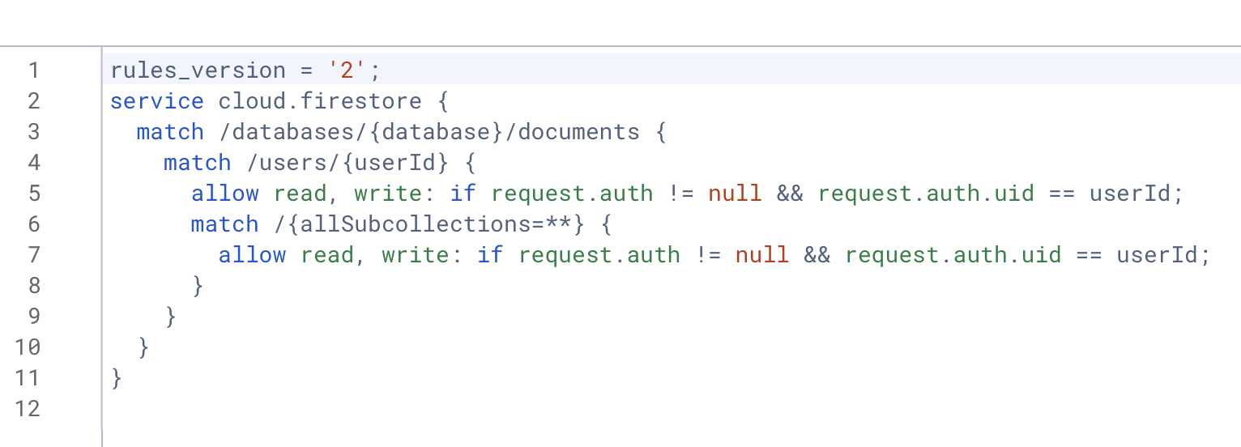I also leveraged Security Rules (for Firestore and Cloud Storage) to enforce data access control based on user authentication (e.g. users can only access their own profile data and CVs).

*Figure 17: Customised Cloud Storage Security Rules*



*Figure 18: Customised Firestore Database Security Rules*

* All client-server communication uses HTTPS encryption.
* For API Security, there are environment variables for sensitive data (e.g. API keys) and input validation on both client and server side. The environment variables assure no keys are exposed on the frontend of the platform.

4.6 Scalability

* Firebase services (Auth, Firestore, Cloud Storage) for automatic scaling
* Microservice architecture separating Express backend and Flask API
* Stateless API design for horizontal scaling

4.7 Usability

**4.7.1 Responsive Design**

* Tailwind CSS for responsive layouts
* Mobile-first approach with flexible grid systems
* Consistent styling across components
* Loading states and transitions (DottedLoader)
* Toast notifications for user feedback (using React’s toastify package)
* Guided user flows (survey completion, CV upload)
* Friendly, modern and student-appropriate UI design
* Interactive map interface with Google Maps integration
* Consistent navigation with collapsible sidebar (hamburger menu)

**4.7.2 Accessibility**

* Semantic HTML structure
* ARIA labels and roles
* Keyboard navigation support

5 Implementation

5.1 Development Process

I used an agile approach to build the system. Features were implemented in sprints, with each sprint focusing on a specific component or functionality. For example, core infrastructure setup (authentication, database etc), user interface components (e.g. map, profile, survey), integration with external APIs and machine learning services development.

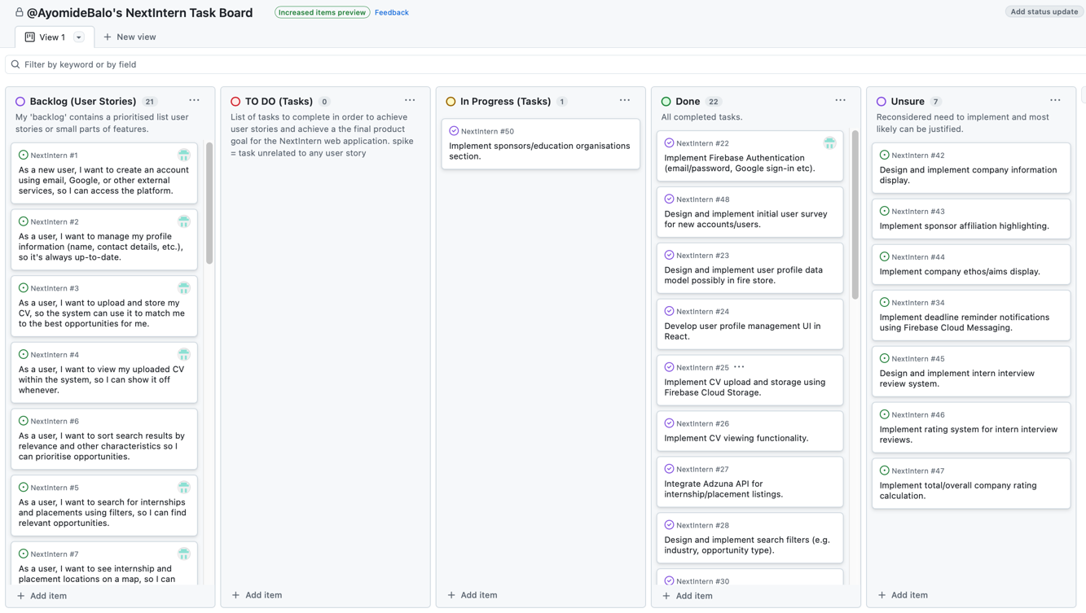I first created user stories from my list of requirements established earlier in the project (within my interim report). I created a project board on GitHub and put all created user stories on the board (in the backlog). Shortly afterwards, I devised a clear list of tasks that would lead to all the user stories being achieved. The tasks were added to the ‘TO DO’ column of my project board, intending to progress through ‘In Progress’ eventually to ‘Done’ column. The tasks on my project board are all linked to their related user stories. Although I have been using GitHub for version control and project management, I plan to mirror my project to GitLab per the university’s preference.

*Figure 19: Project board including User Stories and Tasks List*

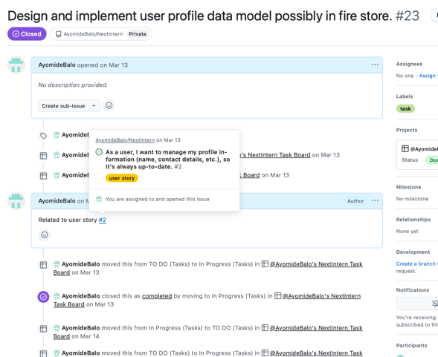

*Figure 20: How tasks were linked to related user stories*

To track my progress throughout the project I filled a weekly progress log detailing key updates, what went well and what did not go well. I also took screenshots of the progress board to show progression over time. The ‘Unsure’ column contains features I grew to not implement with reasonable justifications.

5.2 Key Features

The two core and non-trivial features of the NextIntern platform are the **match score calculator and the skill gap analyser.**

The match score feature is able to produce an accurate match score between the user and any found opportunity. It gives the user a good idea of their suitability for a particular role, restoring the confidence lost due in the modern untailored application tools. Lower scores work to prompt uses to opt for a skill gap analysis (via the tool gap analysis feature) to provide substantial, actionable feedback on how to acquire missing skills to close the gap and become more suited for the role (if they truly desire it).

5.3 Key Resources

Implemented within the Flask API service, the **CVPredictor** class controls the match scoring functionalities. The class quantitatively compares CV relevance against particular internship postings.

**Initialisation & Core Tools (CVPredictor.__init__)**

The class loads key resources upon creation, including:

**5.3.1 spaCy (en_core_web_lg)**

* **spaCy** is a free open-sourced Python library that provides pre-trained models for various natural language processing (NLP) tasks [39, 40,41]. **en_core_web_lg** is one of spaCy’s models. **en_core_web_lg** is a large spaCy NLP model (English) used for advanced NLP tasks, particularly Named Entity Recognition (NER) and semantic similarity calculations based on word vectors. For me, using SpaCy's en_core_web_lg, allowed me to achieve my aim of incorporating a natural language processor into my code. This aim was targeted at my suitability scoring because it provides pre-trained word vectors and semantic similarity capabilities that allow you to understand the true meaning and relationships between skills/requirements beyond simple keyword matching. For example, recognising that "software development" and "programming" are highly related concepts even though they don't share exact keywords, leads to more accurate CV-job matching scores. This is what takes my application further than other internship applications that may use suitability scoring, such as linkedin who explicitly just use keyword matching of job listing skills and skills entered in profile by user.

**5.3.2 Sentence Transformers (all-MiniLM-L6-v2)**

* A sentence transformer model used to generate dense vector embeddings (numerical representations) of text, enabling further efficient semantic similarity comparisons using cosine similarity. Computers can’t directly compare text for similarity (contextually), therefore when comparing text (in our case two different CV’s), we need to convert the text into numbers (vectors) that are able to capture their meaning. A broader term used for this is ‘encoding’ which means to convert data into a specific format. The key advantage of Sentence Transformers is that they are able to capture the contextual meaning of entire sentences or paragraphs, not just individual words in isolation [45]. This is achieved through the architecture of the model and how the models are trained. Ultimately, they are trained using objectives that encourage semantically similar sentences to have close vector embeddings. This particular sentence transformer model is based on Microsoft's MiniLM architecture and fine-tuned on large-scale datasets.

**5.3.3 Pandas DataFrames**

* Pandas DataFrames to load pre-processed resume_dataset and skills_dataset [48]. The resume dataset holds a large set of job categories (jobs) and the CV’s of those that have secured roles within those job categories. The resume dataset was sourced through a github repository and comprises resumes through scrapping of Google images, Bing images and LiveCareer [35]. The repository owner implemented extensive filtering procedures to verify the quality of the data. This includes used optimal character recognition (OCR) algorithms to extract textual content form the images. The skills dataset was maticulously created by myself in a Google spreadsheets. Large sets of job categories (within finance, technology and law) and their sought after skills were inputted into the spreadsheet under the columns job_link and job_skills. These job categories and skills were generated using domain knowledge and generative artificial intelligence tool Gemini. All generated job categories and skills were manually vetted before inclusion. I originally attempted to utilise a dataset found on kaggle (with the same column names), but wanted to assure the data was closely suited to the fields of interest for my software and not leaving out any underlooked roles within the three fields.

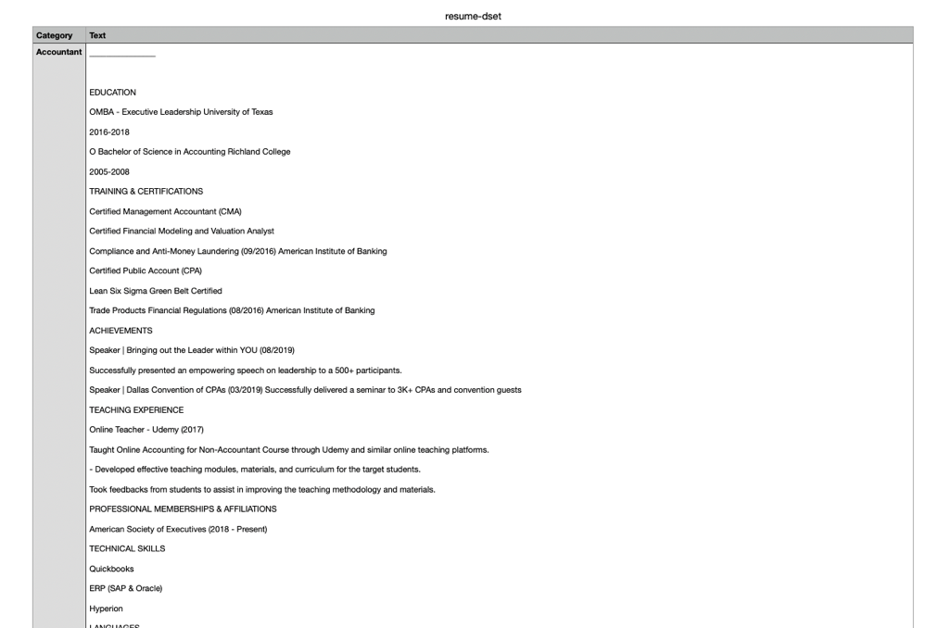

*Figure 21: Snippet of Resume Dataset*

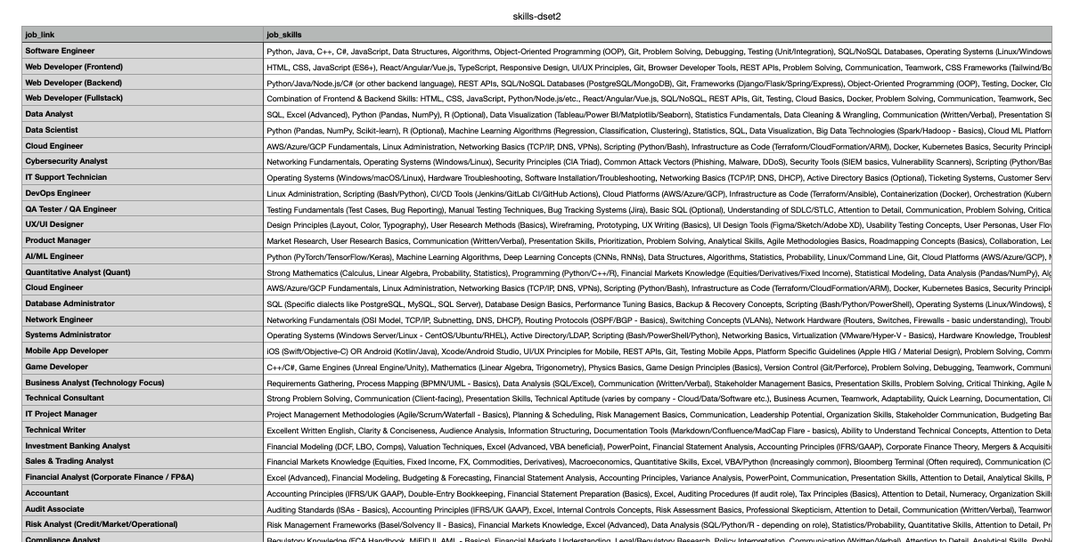

*Figure 22: Snippet of Skills Dataset*

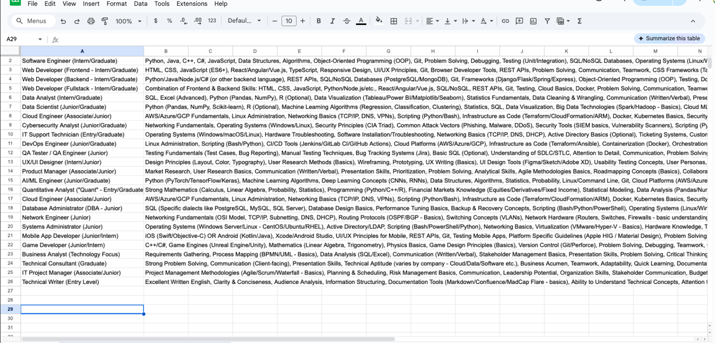

*Figure 23: Image describing the dataset creation process*

**5.3.4 NLTK Stopwords**

* Used for basic text cleaning [46,47].

**5.3.5 Custom Skill Patterns (_initialise_skill_patterns):**

* The spaCy pipeline is enhanced using its EntityRuler with custom patterns I tailored for Tech, Finance, and Law domains. These patterns explicitly define multi-word skills (e.g., "machine learning"), job titles, degree types and certifications, allowing the NER model to accurately extract domain-specific terms beyond its default capabilities.

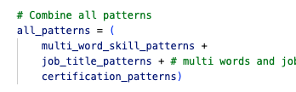

*Figure 24: Code combining the three custom patterns tailored*

**5.3.6 CV Parsing (parse_cv)**:

* This method takes raw CV text, processes it with the customised spaCy natural language processing object, and extracts entities identified by the enhanced Named Entity Recognition (specifically SKILL, DEGREE, JOB_TITLE labels). It also uses a simple heuristic to identify sentences likely describing work experience. Duplicates are removed from the extracted information and the extracted information is returned as a structured dictionary.

**5.3.7 Match Score Calculation (calculate_match_score)**:

* This central function determines the match percentage between the parsed cv_data and a given job_description and job_title. A process involving several steps…

5.4 Match Score Implementation (cv_predictor.py)

**5.4.1 Category Matching (_find_similar_job_category)**

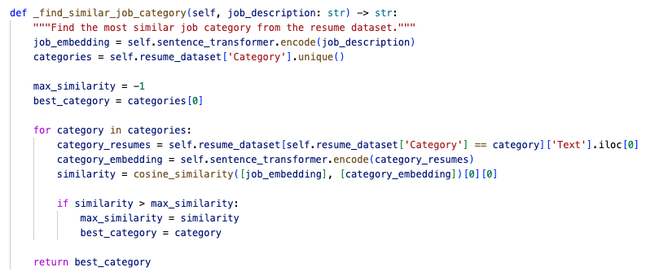

*Figure 25: Function for Finding the Most Similar Job Category*

The job title/description is encoded using the Sentence Transformer. This embedding is compared against embeddings of text from different job categories in the resume_dataset. Cosine similarity is then used to identify the most relevant job category (best_category). This is achieved by searching for the highest cosine similarity between the resume’s data set jobs and the user chosen job on the web application. Cosine similarity is particularly effective here because it measures the similarity between two vectors based on the angle between them rather than their magnitude. This is crucial as it allows the system to identify job categories with similar semantic meaning, regardless of the length or ‘size’ of the text used to describe them

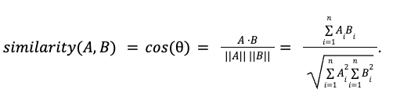

*Figure 26: Cosine Similarity Formula [38]*

**5.4.2 Reference Resume Selection**

The best_category extracted from the cosine similarity serves as the most relevant job (‘job category’) from the dataset to which we found the best_resume and can proceed to hyper-focusing on the cv’s that resulted in this ‘most similar job’ (to the desired job/role of the user) being secured. Eventually, the system finds the single resume ([best_resume] within all the different rows of resumes with the same job as the best_category (e.g. different rows all with job category ‘Data Science’), where the Sentence Transformer embedding of that resume has the highest cosine similarity to the job title/description embedding.  
  
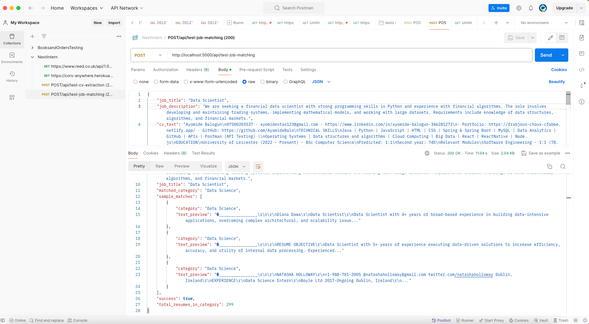

*Figure 27: Testing endpoint implemented that can show example of different relevant resumes being produced from one decided job category (through cosine similarity.*

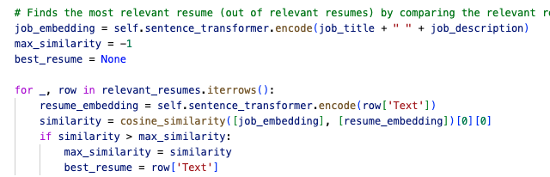

*Figure 28: Function for Finding the Most Relevant Resume for later comparison.*

**5.4.3 Core Match Score Calculation**

The primary match score metric is derived using spaCy's built-in .similarity() method between the spaCy-processed CV text (focused on extracted skills and job titles) and the spaCy-processed best_resume text. The process uses spaCy's word vectors for semantic comparison, providing a score between 0 and 1.

**Use of spaCy’s .similarity() in Final Comparisons**

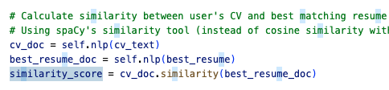For initial resume selection, Sentence Transformers provided context-rich embeddings of **entire** CVs, enabling a broad semantic comparison to identify the most relevant job category based on overall meaning. However, for the final match score, although spaCy’s .similarity() approach technically uses cosine similarity under the hood, spaCy’s and sentence transformers involve different vectors. Sentence transformers use vectors designed to represent the meaning of whole sentences or documents whilst spaCy’s .similarity() uses word-level embeddings that are an average of the word vectors within the document. This pivot allows for a comparison focused on the semantic similarity of the specific skills and job titles extracted from both the user's CV and the chosen best resume, offering a detailed assessment of key professional elements rather than just overall contextual similarity.

*Figure 26: Ultimate comparison between the users CV and the CV of the who we have identified as the best example of someone who has previously attained the same role (or extremely similar role).*

* + **Scoring & Bonus**

 The spaCy similarity score is converted to a percentage. A bonus score (up to 15%) is added via _calculate_title_match_bonus if job titles listed in the CV match the target job title (exact, partial, or common word overlap), with the final score capped at 100.

**5.4.4 Skill Comparison**

Next, the functions _find_matching_skills and _find_missing_skills are called. These compare the skills extracted from the CV against skills required for the job. First, it consults the ‘skills_dataset’ and uses spaCy's semantic similarity to match the job title of the desired job to the most similar job title in the dataset (dataset is loaded with a plethora of unique jobs in finance, law and technology). Once the best match (for job title) is found, it retrieves the job’s associated required skills for comparison with the user's CV skills. To compare the required skills for the job with the users skills, it directly analyses the job description using spaCy's enhanced NER to extract `SKILL` entities, which are then compared to the CV skills through exact, partial, and semantic similarity matching (score > 0.75) to determine whether a skill is a matching skill or missing skill.

* 1. Skill Gap Analyser Implementation (skill_gap_analyser.py)

**5.5.1 Initialisation (SkillGapanalyser.__init__)**

Loads the OPENAI_API_KEY from environment variables (dotenv) and initialises the OpenAI client library.

* + 1. **Analysis Process (analyse_gaps)**

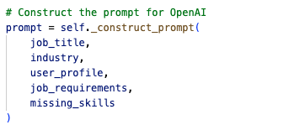This method sets up the generation of skill gap recommendations. It receives job details, user profile information (skills, education, etc.), industry establishment and missing_skills list previously identified within the CVPredictor. These contextual parameters are instrumental in determining a personalised and applicable response (to the user) is returned.

*Figure 27: Parameters for data passed into Generative AI API for Skill Gap Recommendations*

* 1. **Prompt Engineering (_construct_prompt)**:

A detailed prompt is dynamically constructed. Rather than a static prompt, the system builds a unique prompt for each analysis as per the previous contextual parameters provided. A detailed prompt is provided to OpenAI model (gpt-4) instructing the AI to produce desired career development steps, with a well-defined output structure, a preferred tone for my system and very specific constraints (included what not to include). This structured prompting is key to obtaining relevant and useful recommendations for the user.

* 1. **OpenAI API Call (_get_openai_recommendations)**:

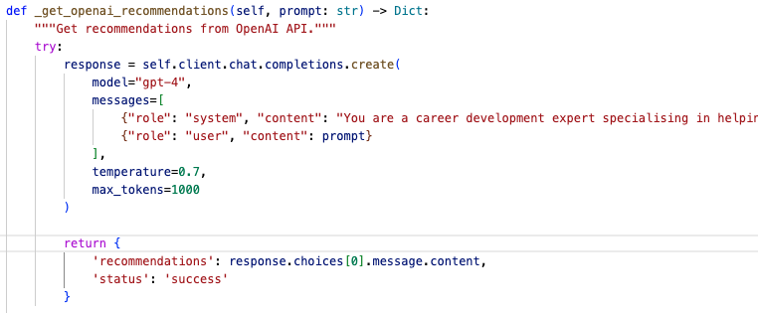The constructed prompt is sent to the OpenAI API via the client.chat.completions.create method. Parameters like temperature (controlling creativity) and max_tokens are set. Basic error handling is also included. The method returns a dictionary containing the AI-generated text recommendations structured according to the prompt's instructions.

**Flask API Endpoints (app.py)**

*Figure 28: Generating the Recommendations Response*

5.6 Flask API Endpoints (app.py)

1. The Flask application acts as the interface to these Python services. It initialises CVPredictor and SkillGapanalyser.
2. CORS (cross-origin resource sharing) is configured to allow requests from the frontend.
3. It defines API endpoints (e.g., /api/analyse-cv, /api/analyse-gaps) using @app.route. These endpoints receive POST requests with JSON data (like CV text, job details, user profile), call the relevant methods on the predictor/analyser instances, handle potential errors, and return the results (match score, analysis, recommendations) as JSON responses to the caller, directly from the frontend. Test endpoints are also included for debugging specific functions.

5.7 Technical Challenges

Throughout the implementation phase, several technical challenges arose requiring intricate considerations and effective solutions. I have outlined the key technical challenges I ran into below, including how I was able to move past them.

**5.7.1 Expo and Node Modules Issues**

Moving from flutter framework and dart programming experimentations (for cross-platform development. I decided to use React-Native due to the larger community and therefore wider support/resources. Here, I ran into a few node_modules errors pertaining to my program being unable to locate certain folders that I had verified to exist within my program (and within the node_modules package). Using critical thinking to infer back to my main project objectives and evaluate the project scope, I identified cross-platform development (in general) as a major potential time constraint and decided to focus on developing solely a ‘web’ application using React framework instead.

Moving to React I experienced the same node_modules error whilst implementing my user onboarding survey using the surveyJS library. This time, I solved this error with careful steps. First, I manually searched the node_modules package and relevant folders to find the exact file attempting to be reached by the software. After verifying the files existence, I searched previous experiences with this error on stack overflow. In doing so I was able to discover the error came from the spaces in my main project folder name, causing a confusion to which node_modules from another similarly named folder on my desktop was being called instead. Upon fixing the folder name, by removing blank spaces and replacing them with underscores, and then rebuilding node_modules, my node_modules errors were fixed and did not return.

**5.7.2 Cross-Origin Resource Sharing Challenges**

I faced CORS issues whilst trying to make direct calls to Adzuna (job listings API). At first, I solved this temporarily by using cors-anywhere. CORS anywhere is a service that acts as a proxy to bypass the Same-Origin Policy enforced by web browsers. It does this by fetching the resource wanted from a different domain, adding the necessary CORS headers and sending the modified response back to the browser, tricking the browser into thinking the data originated from the same domain as my frontend. This could only be a temporary fix, as trusting the third-party service to handle the data securely could be risky if a security vulnerability were to occur on the CORS anywhere server. I eventually set up my code base more intentionally to handle frontend to backend communication properly. I created a proper Express backend. Implemented CORS configuration in both frontend and backend. Set up CORS rules in cors.json for frontend and backend environments and used environment variables (stored in my .env) to manage CORS origins. Dedicated service files for fetching the internship opportunities (such as BackendAdzunaService.js) were also created.

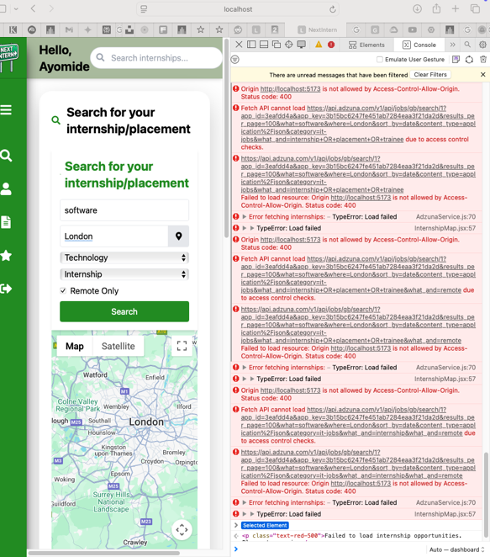

*Figure 29: CORS Errors Blocking Internship Search*

**5.7.3 CV Extraction Issues**

At a point during the project, I faced challenges with processing cv data parsing and cv extraction. As a result, I was receiving low match scores on my platform whilst testing it against my CV, even from opportunities that I knew suited my CV content and profile (certainty derived from domain knowledge). By creating test endpoint to verify CV extraction accuracy, I was quickly able to solve this and refine my code carefully to allow my match scoring system to be accurate and useful. I implemented data sanitisation to validate data before processing and added suitable error handling for missing or malformed data.

**5.7.4 Cloud Deployment**

I made a considerable attempt at deploying my project using Oracle Cloud [58]. A significant amount of time was invested in setting up a Virtual Network (VCN), creating a compute instance within a chosen region, and transferring the project codebase (including the existing Python virtual environment) from local development and GitHub. Both Flask and Express development servers were successfully launched and managed using service files. A shared configuration file with server endpoints and the instance's public IP address was created.

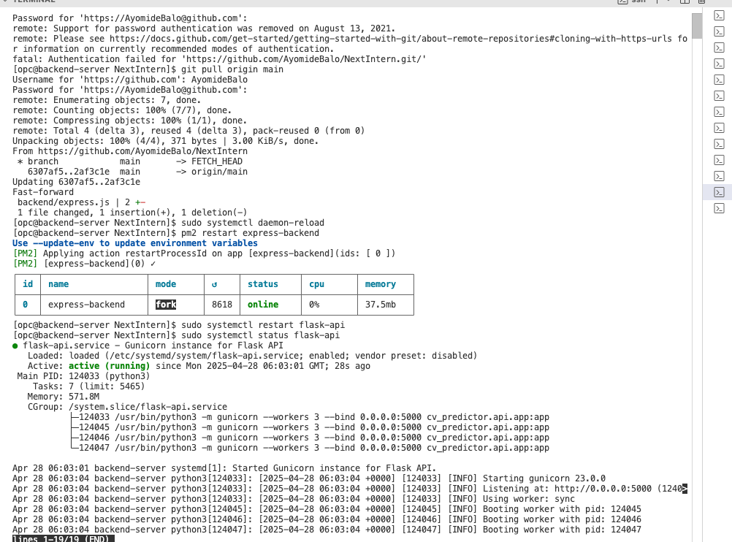

*Figure 30: Express.js and Flask backend servers running successfully on the cloud instance.*

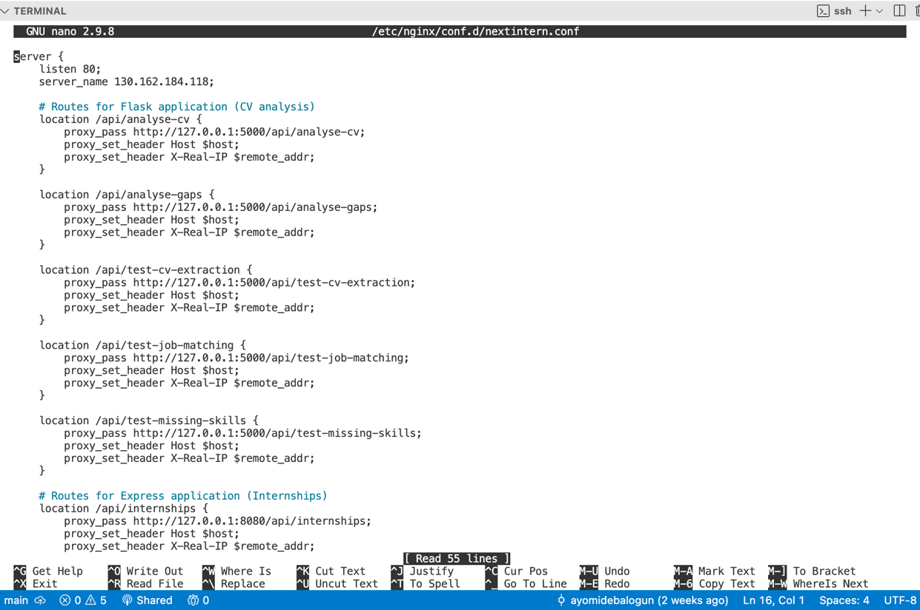

*Figure 31: Reverse Proxy Setup for Express.js and Flask including their various routes (configuration file).*

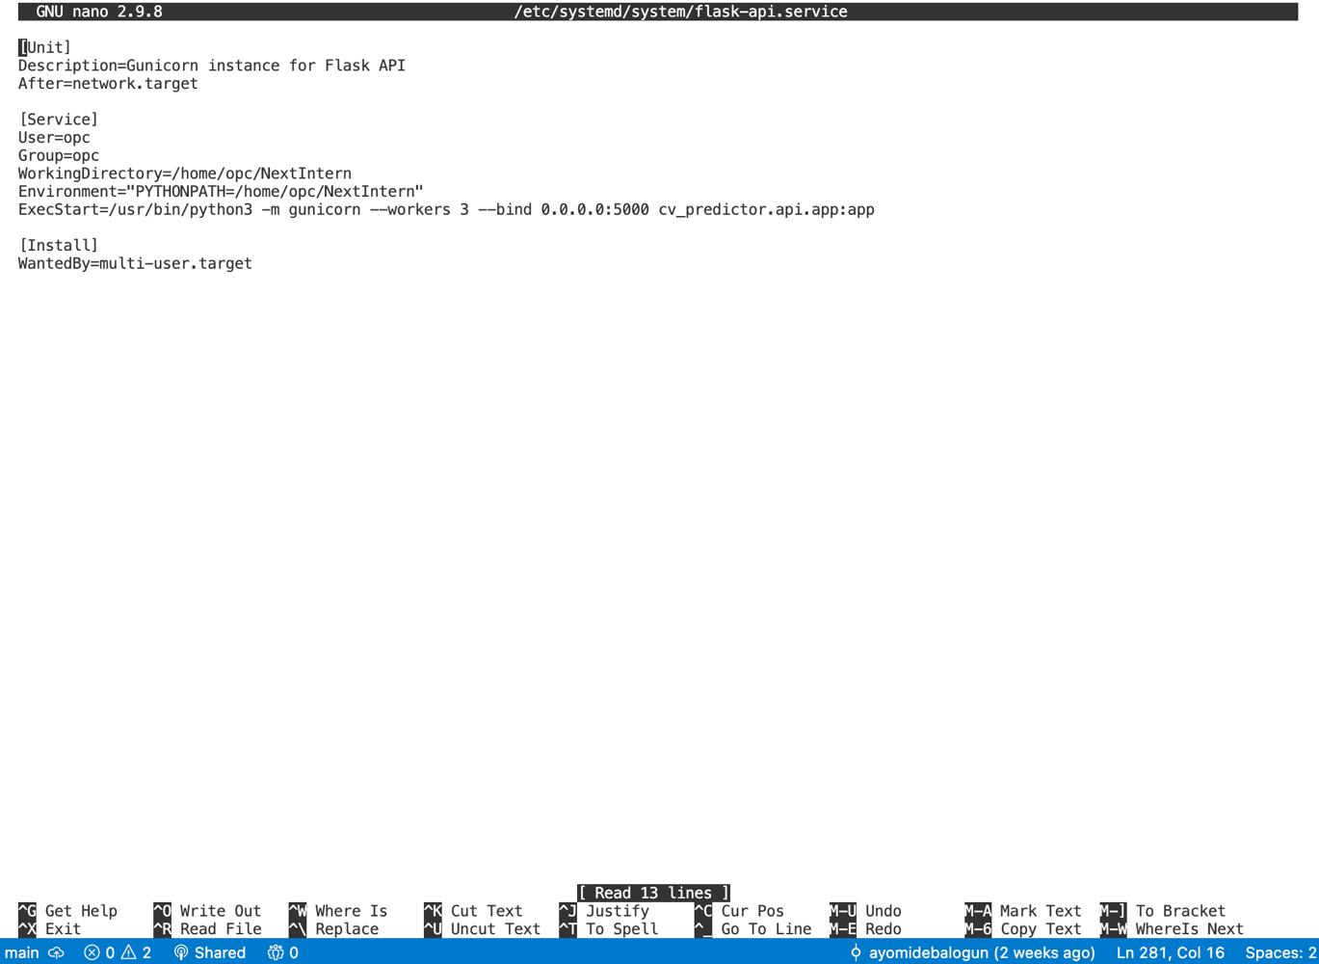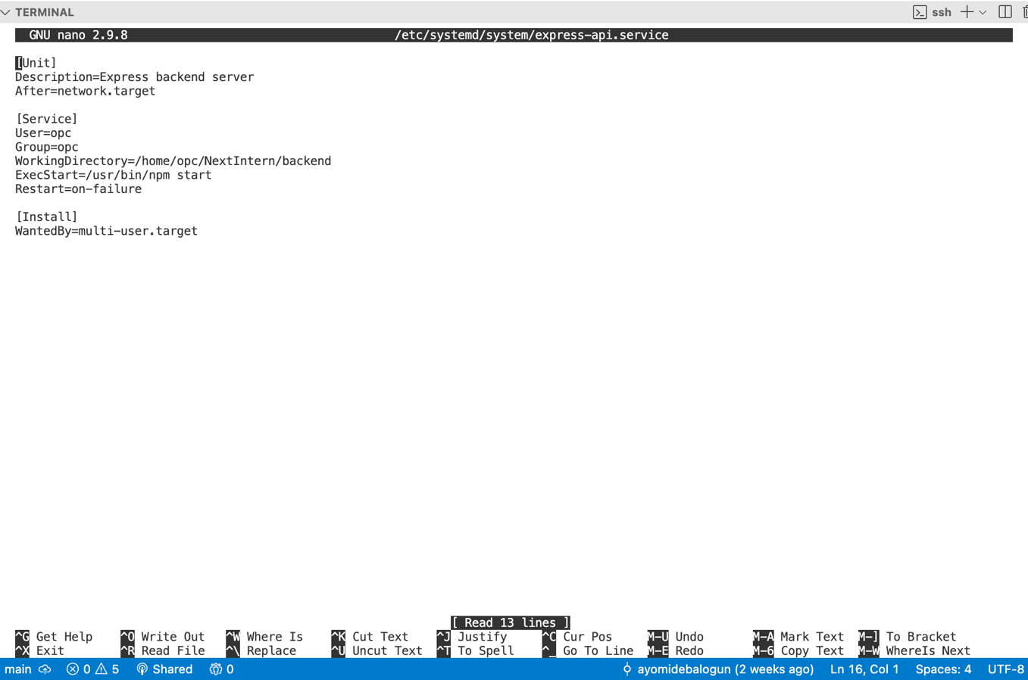

*Figure 32: Express and Flask Systemd Service Files*

However, integrating the cloud-hosted backend with the Netlify-deployed frontend ended the lengthy attempt. Despite providing Netlify with the cloud server's IP address as an environment variable for API calls, CORS permission issues arose when frontend components attempted to interact with the backend. Eventual implementation of Netlify's proxy offered a temporary workaround for the Express server however the Flask backend consistently failed to resolve the CORS issues. Due to time constraints and the need to prioritise other aspects of project completion, the cloud deployment endeavour was abandoned. Upon reflection, I have a few ideas as to what may have been the issue. It could have been that I first transferred the project from GitHub, forgetting about critical files I had stored in .gitignore due to size (e.g. my datasets used in the Flask backend). I also understand that the cloud server can have its own curated URL, however I was using the alternative option of using the cloud servers IP instead of URL which may have not been ideal. Finally, the separation of my backend into two internal servers could have risen issues, combining my backend generally may have eliminated certain issues throughout. The cloud deployment attempt is not reflective through commits as I used ‘git hard reset’ command to navigate to before the endeavour. Admittedly, creating a new branch for cloud deployment may have been better to preserve the attempt.

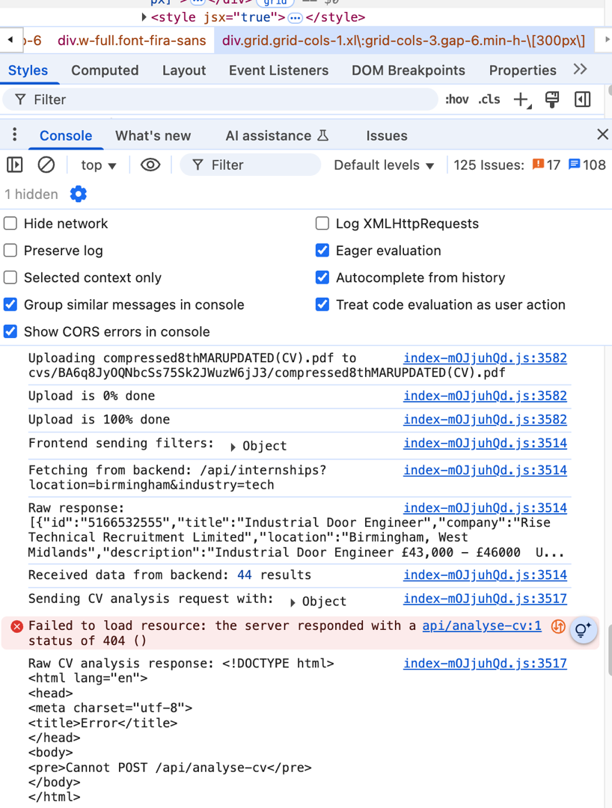

*Figure 33: Successfully Express Backend Call but Unsuccessful Flask Call*

6 Testing and Evaluation

Throughout the project, I implemented a variety of software testing approaches. This was crucial in upholding my project goal of producing an industry standard and releasable software to which the meeting of the project requirements had been verified, defects identified early, screen size and browser compatibilities tested, and potential future performance issues predicted. These checks helped me to improve my confidence/clarify in the software’s current quality.

Some of the testing strategies I employed include unit, integration, system, and user testing.

6.1 Unit Testing

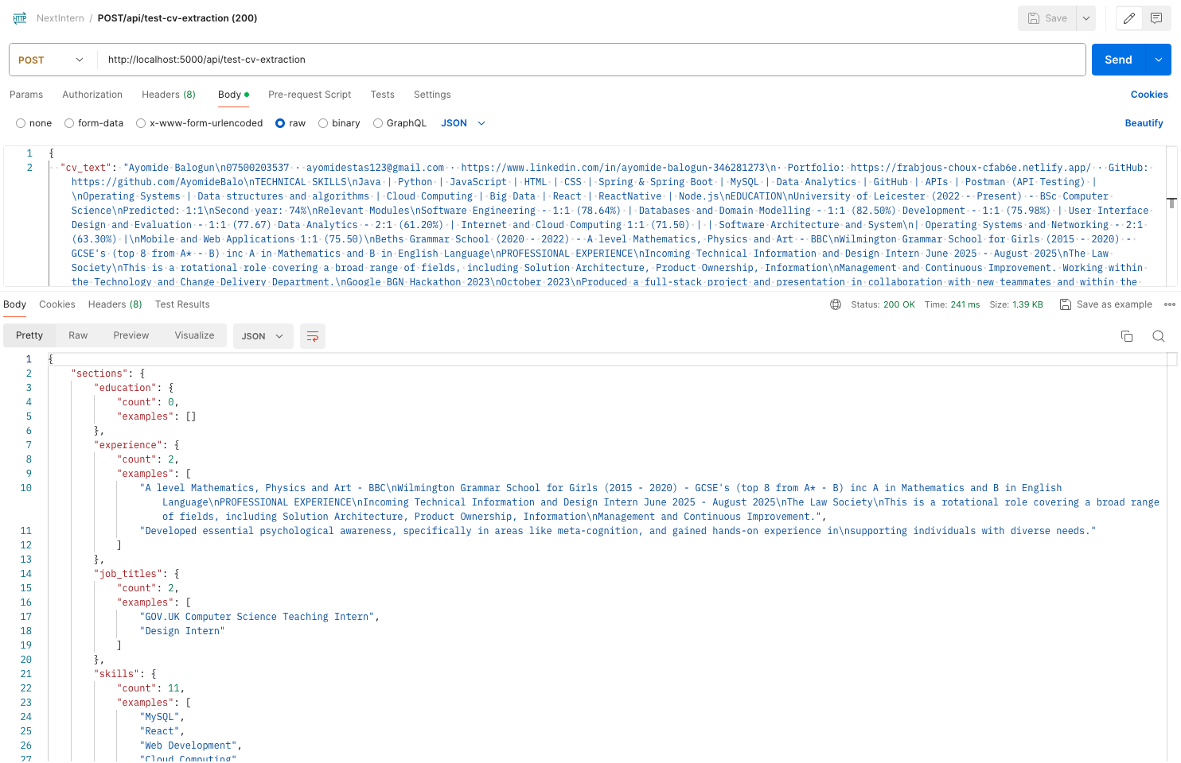Unit testing was implemented within the Flask API, evidenced by dedicated test endpoints such as /api/test-cv-extraction, /api/test-job-matching, and /api/test-missing-skills. I tested these endpoints using Postman (API platform for designing, testing and documenting APIs). This allowed me to isolate individual components of the CV match scoring (or analysis) and the skill gap analysis functionalities, verifying the components individually. By doing so I ensured the CV data was being parsed correctly, the datasets processed correctly and the two being used against each other accurately. After enduring some issues pertaining to a low match score, I discovered that the CV data was not being parsed properly, resulting in the low score. Implementing unit tests helped drastically and fundamentally verified the functionality of the CV match scoring feature.

*Figure 34: Example API Response for CV Extraction Unit Test (Postman)*

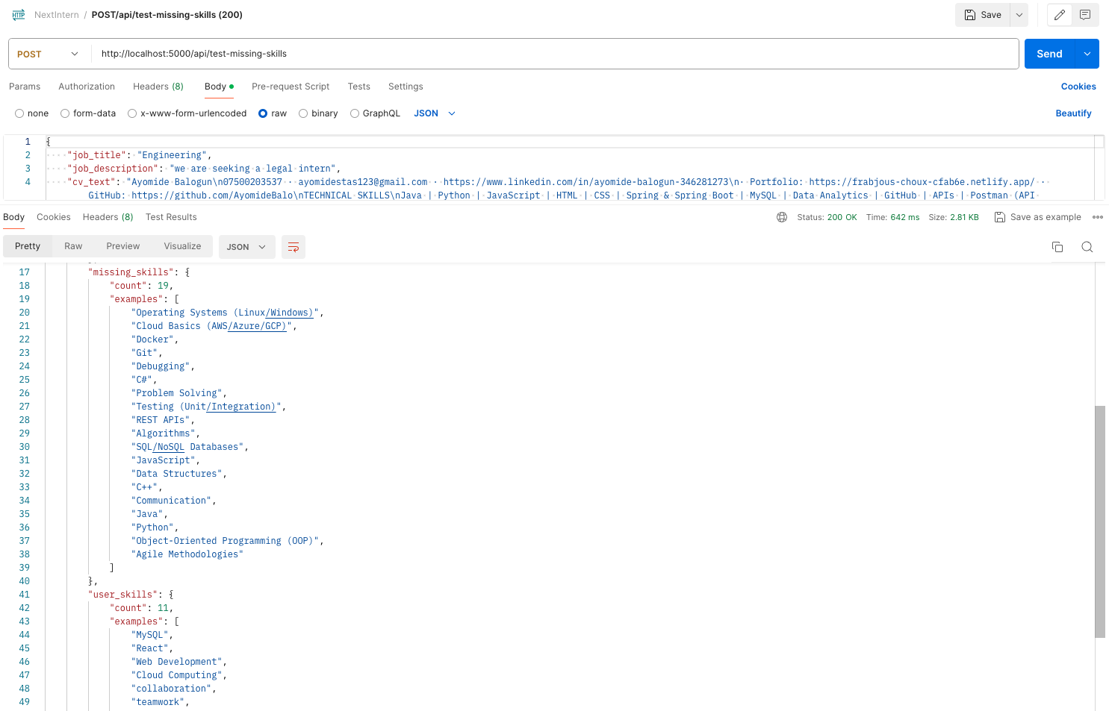

*Figure 35: Example API Response for Missing Skills Unit Test (Postman)*

Input **validation** was implemented throughout, particularly in frontend components like InternshipMap.jsx (validating location and industry are definitely selected for an opportunity search). Additionally, comprehensive **error handling** was integrated into backend services (e.g. AnalysisService.js provides specific error messages for scenarios such as a user attempting a match score with a missing CV).

6.2 Integration Testing

I implemented integration testing to verify interactions between different components. The AdzunaService.js demonstrates integration testing through its error handling and logging of API calls to the external Adzuna API (axios.get in internships.js), ensuring informative error messages in case of API issues. The direct API calls from the frontend's AnalysisService.js to the Flask API (fetch requests to http://localhost:5000/api/analyse-cv and /api/analyse-gaps) also represent integration points that were monitored for correct data exchange and error propagation. I monitored requests and tested integrations mainly by utilising the browser’s developer tools (by inspecting the page) to inspect the HTTP requests and responses exchanged between the frontend and backend services. *Figure 29* shows an example of this. I also manually tested and observed user workflows that involved interactions between different services. At times, I even directly tested the functionality of these API calls using Postman by manually constructing URLs with sample parameters (such as specific location, industry and whether a ‘remote’ opportunity was preferred or not). This also helped in ensuring correct data was being retrieved from the Adzuna API.

6.3 System testing

System testing involved end-to-end testing of complete user workflows. This included manually verifying that protected routes (such as the dashboard after signup) were inaccessible before the user completed the initial survey and became accessible afterwards. State management was also tested by navigating between different routes (e.g. between the internship map and other pages, confirming that the map state was preserved). Another reason this was important to me besides a more optimal user experience, I wanted to prevent unnecessary API calls that could have triggered the API to reach its cap.

6.4 Reliability and Robustness

I made sure that edge cases, such as missing CVs (handled in AnalysisService.js), missing location inputs (validated in internshipsController.js), and potential API failures (handled in internshipController.js), were anticipated and addressed with appropriate error messaging and control flow. The logging implemented in both the frontend (console.log, console.error in AdzunaService.js and AnalysisService.js) and backend (console.log, console.error in  internshipsController.js and Flask routes) aids in monitoring the application's behaviour and distinguishing potential issues. These implementations enhance software reliability by handling unexpected situations and maintaining operational stability.

7 Results and Discussion

7.1 Exploring NextIntern

Thorough testing strategies allowed me to validate functionality and effectiveness of the NextIntern platform. Here are the results of my implementation and testing:

*Figure 36: Once user decides to get started with NextIntern, they are greeted by the log in page.*

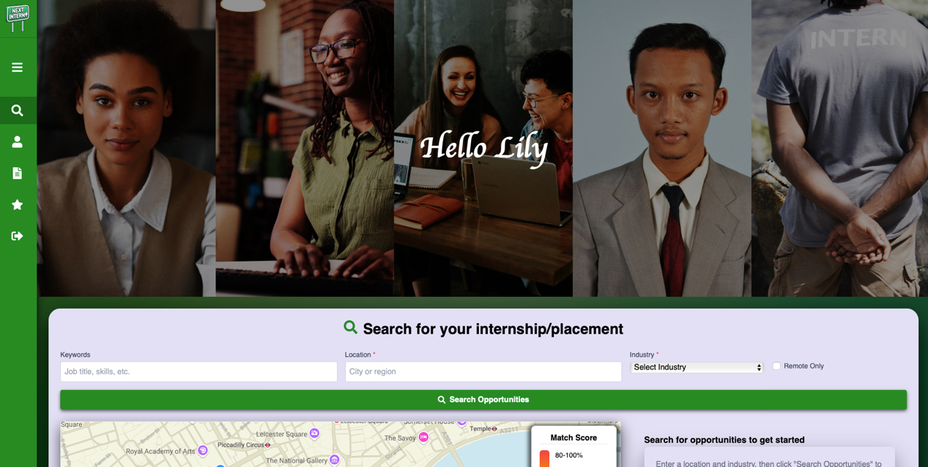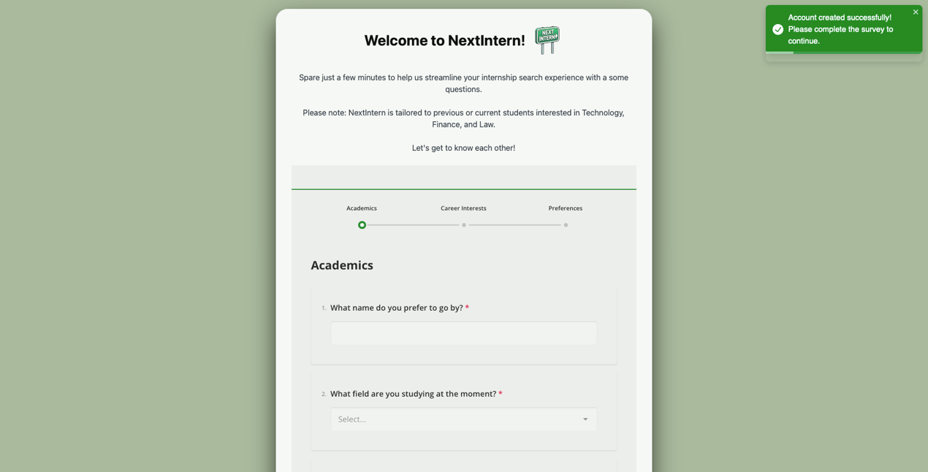

*Figure 37: First time account creation immediately followed by mandatory user onboarding survey*

*Figure 38: Main page (search page) welcomes the user with friendly and aesthetically pleasing UI design. Design parses the users Name from the survey (the survey forms the users ‘profile’)*

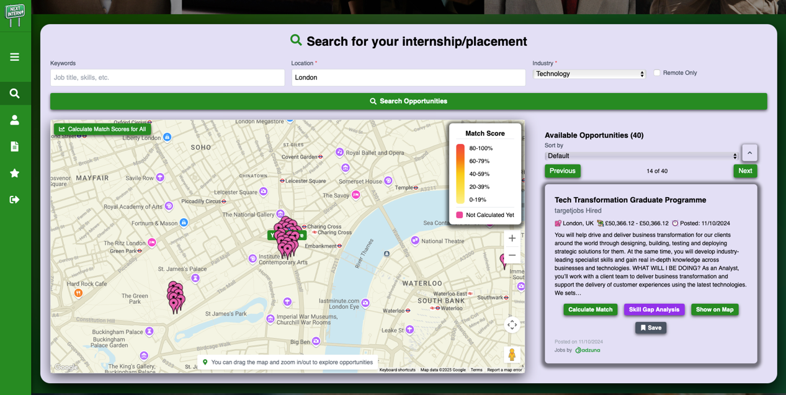

*Figure 39: Home page features internship search tool with map-based filtering. Figure shows results for technology opportunities in London.*

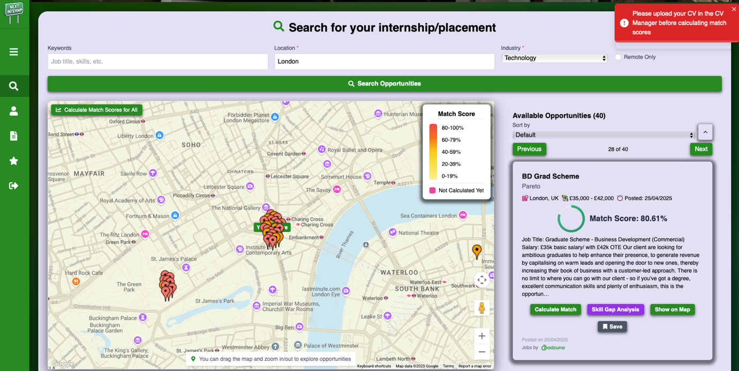

*Figure 40: As user attempts a match score without a CV uploaded, user is prompted to upload CV first.*

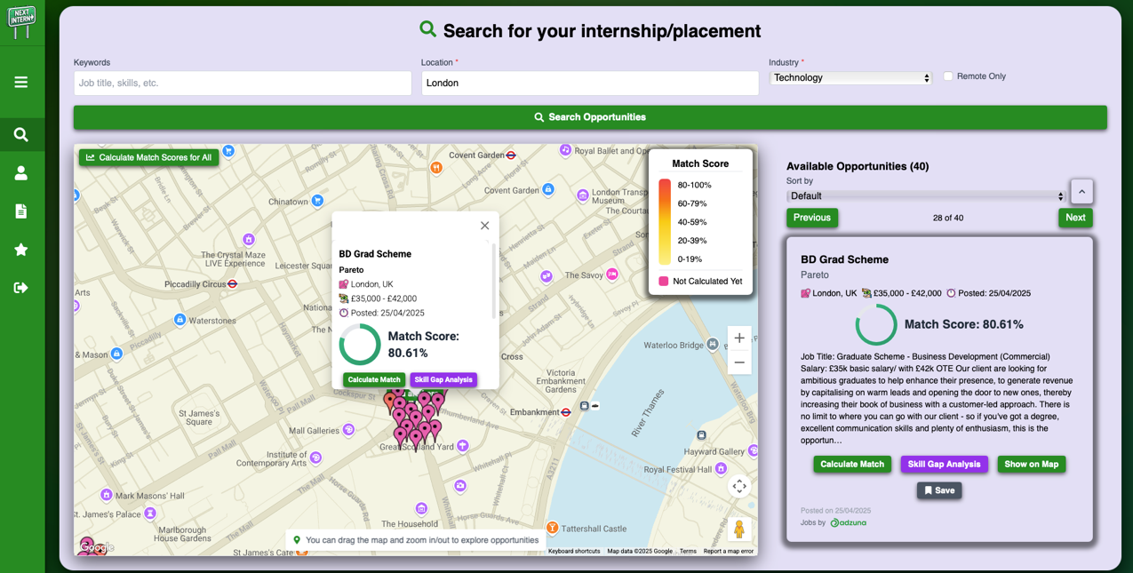

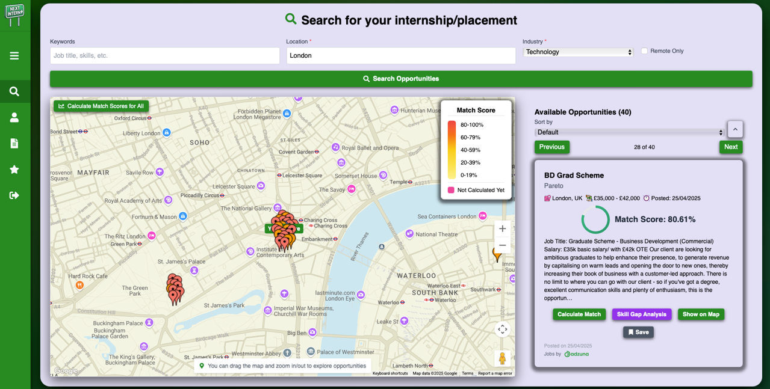

*Figure 41: Match scoring feature against a technology-based graduate scheme in London. The percentage indicates the suitability based on users skills, experience and overall profile.*

*Figure 42: Location pins for opportunities are colour-coded by Match Score (as match scores are calculated).*

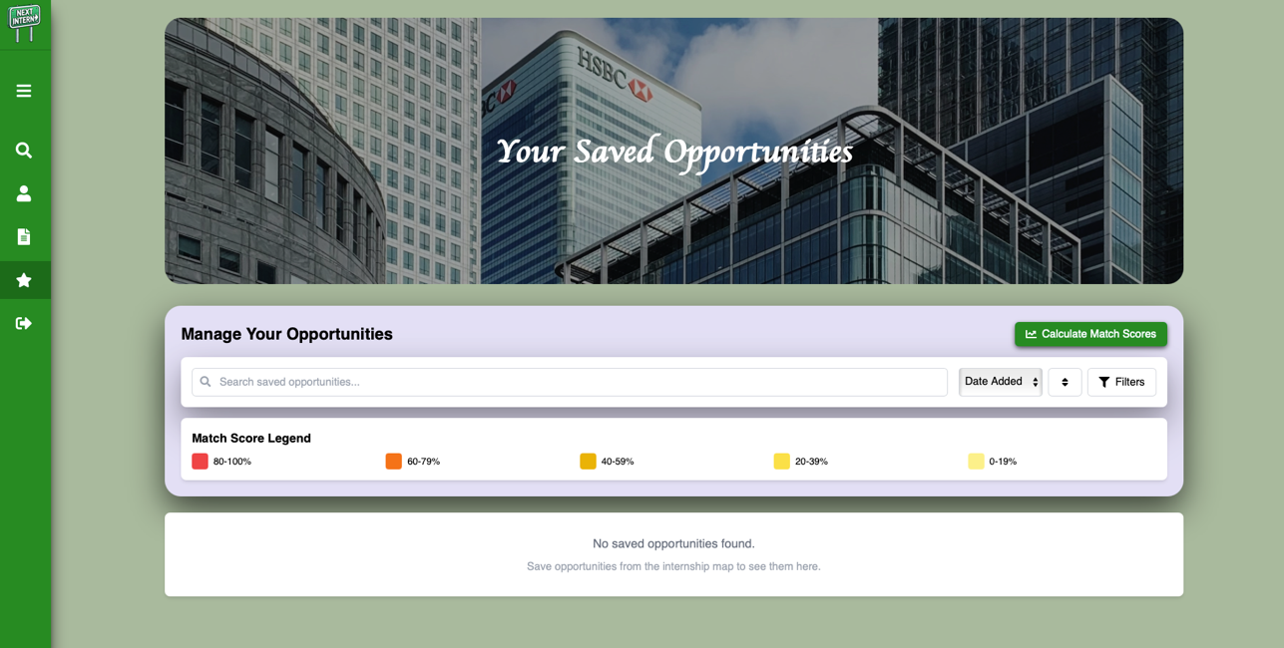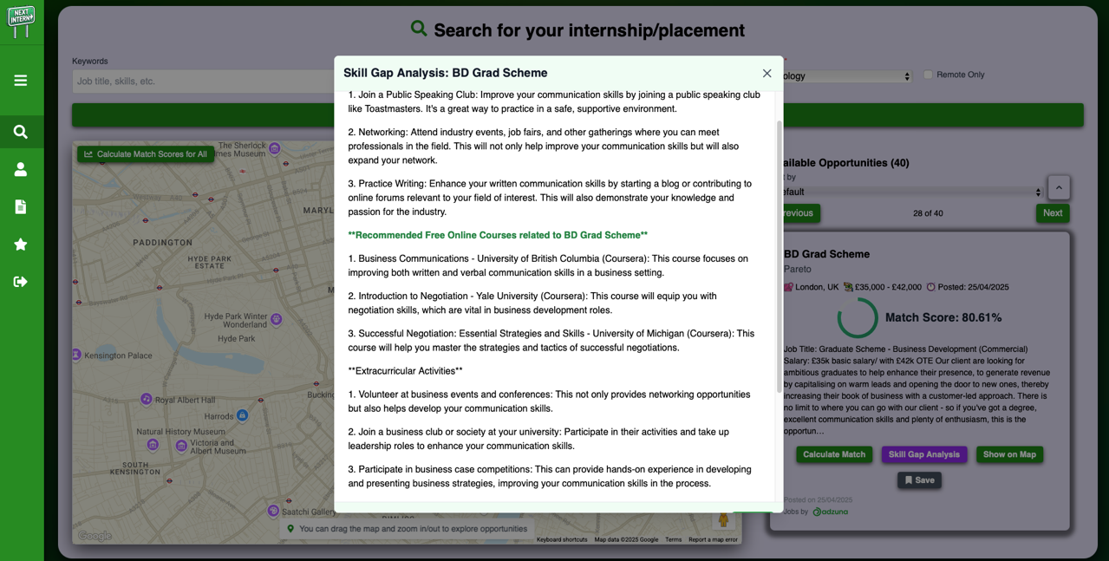

*Figure 43: Skill gap analysis on a technology-based graduate scheme in London. Addresses missing skills for the desired internship role.*

*Figure 44: Saved Opportunities page. Users have the option to save opportunities on the main page.*

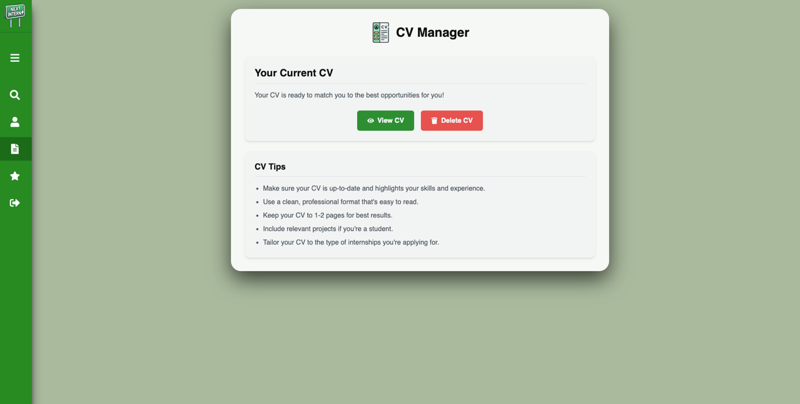

*Figure 45: Skill gap analysis on a technology-based graduate scheme in London*

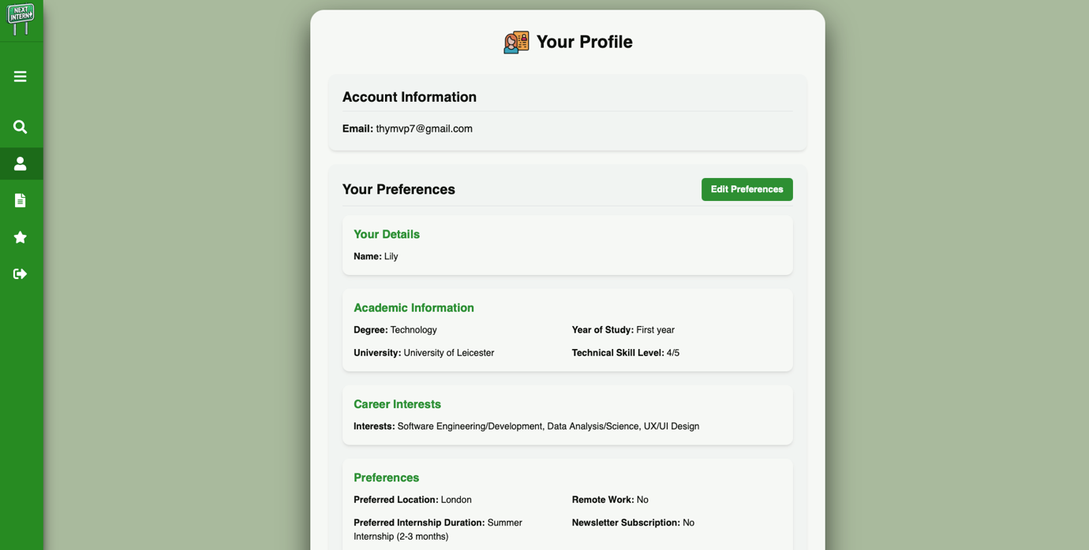

*Figure 46: User profile (page) based on initial onboarding survey.*

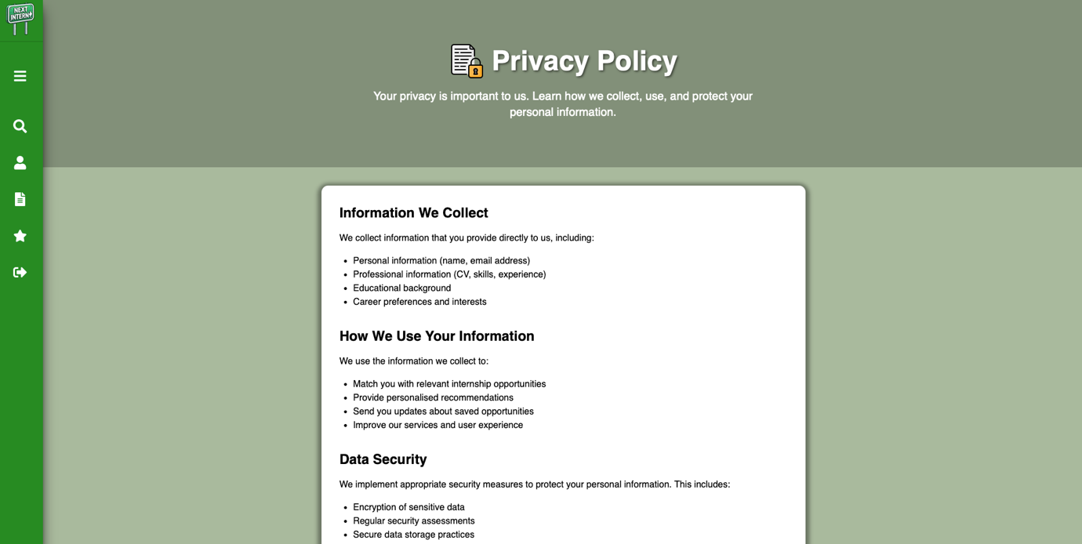

*Figure 47: Privacy Policy page outlining how the users personal information is collected, used and protected on the platform.*

7.2 Analysis

The results align with the project's aims and achieve all initial objectives. The location-based filtering (*Figure 39*) directly addresses the dire need in existing platforms, to highlight location as a more important/considered factor in attaining a suitable opportunity. The machine learning-based matching tool (*Figure 41*) provides a more personalised (and therefore more accurate) suitability assessment than simple keyword matching, boosting user confidence when needed and increasing the features usefulness. The AI-powered skill gap analysis (*Figure 43*) offers actionable steps for skill development, directly supporting students in enhancing their employability rather than leaving students with no guidance. The intuitive UI, a key objective, was positively received during initial user observation. Furthermore, friendly, student-suitable user interface, designed with inviting visuals and a less overwhelming layout, promotes easy navigation and usability, aiming to decrease additional stress typically added to the internship process through confusing and dull interfaces [57]. The platform avoids information overload and includes helpful features like the ability to save opportunities for later review.  
  
Maintaining a professional standard was a key consideration throughout the project. For instance, to ensure GDPR compliance, the Adzuna API was intentionally chosen over web scraping job listing sites, which mitigates potential legal and ethical concerns related to user data. Following Adzuna's API regulations meticulously, every job listing integrated into NextIntern includes the mandatory ‘Jobs by Adzuna’ highlighting along with their logo, adhering to their terms of service. Additionally, the Privacy Policy explicitly details how user information is collected, ensuring complete transparency, 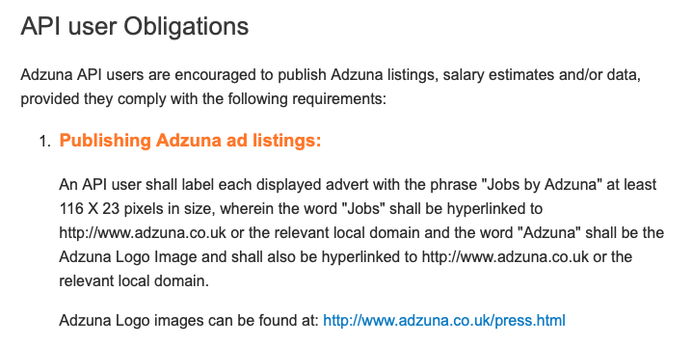building user trust and eliminating worries.

*Figure 48: Adzuna API users terms of service regarding job listings*

7.3 Comparison to Literature

NextIntern's features address limitations identified in existing platforms. Unlike the manual and inconsistently updated listings on platforms such as ‘Bristol Tracker’, the Adzuna API integration provides a continuous stream of opportunities. The map-based filtering is a novel approach unseen in internship tools, highlighting a key consideration. The advanced NLP-driven matching surpasses the surface-level skill matching of LinkedIn by opting to contextually understand users. The personalised skill gap analysis offers more tailored guidance than the general insights found on existing internship such as ‘RateMyPlacement’.

7.4 Implications

NextIntern has the potential to pave the way for other internship/student opportunity centric application platforms, to incorporate more advanced technologies in guiding students and cultivating a more supportive and successful space. NextIntern also highlights the importance of user-centered design (where UI & UX are aspects usually undermined by these type of platforms). Future work could involve further refinement of the machine-learning algorithms and AI incorporation based on larger more accurate datasets.

8 Reflection and Conclusions

8.1 Critical Self-assessment

NextIntern’s user interface achieved my desire of a platform that could distinguish the correct balance between playful and professional. The unique features and fresh take serve as key successes, I believe it truly reflects the detail to which I used to evaluate the problem scope and my creativity. However, admittedly, concerns remain regarding the verifiability of the resume dataset and concerns with Adzuna's data sourcing methods.

I attempted to stick to industry-standard throughout the project to reflect the real usability of my platform and ideas in the real world. This led to me picking Adzuna’s API to provide suitable job listings. Adzuna presents itself as a job search engine that acquires opportunities through partnerships (evidenced online through their job posting features and policies for companies who want to join), however, further research lead me to discover that they **also** may be involved in unverifiable web scraping (to which I avoided due to compliance regulation of some of the companies/sites that provide listings you would scrape). Discovery in their web scraping participation was found on their Adzuna Intelligence ‘About’ page. Web scraping itself is not the issue, it depends on how and who they are web scraping. Reflecting on my decision to use Adzuna, I acknowledge the possibility that my evaluation was partially incorrect, broadening my thoughts to other unverifiable aspects. The repository owner of the resume dataset detailed to have attained the resumes in the dataset from Google images, Bing Images and LiveCareer, publicly available sources that are not behind a wall. However, on reflection, certain claims within the industry, cannot always be verified. Furthermore, this technique in attaining resumes for the dataset could potentially serve as a limitation due to a ratio of the attained resumes being potentially illegitimate [35]. This is because control over the legitimacy of resumes on google images is inevitably narrowed. In terms of other elements, I can confess could be improved within my project; the initial feature list was overly ambitious. My time planning did not correctly weigh implementation complexities of particular features compared to other less complex features. Many implementation processes were underestimated, more research may have revealed this to me earlier. For example, at a point I aimed for cross-platform development (using a single code base), however I was unaware of the requirement of consistent maintenance across ios and android files to maintain compatibilities despite ‘single codebase’. The correct weighing of complexities would have allowed me to consider time constraints against features/implementations more accurately, avoiding attempts that shortly led to realisations that my attention was better off diverted elsewhere in my project goals). Additionally, I experienced an ethical learning curve regarding user testing. Despite extensive efforts to conduct various usability test and collect informative surveys regarding the platform (amongst students in the targeted fields), I was unable to include this while finally reporting on my software project. Although all participants formally consented to their involvement, I learnt that academic research standards prohibit inclusion of human participation in research without an ethics form approved by the academic institution. It was safer for me to prioritise ethics, learn my lesson in academic research standards and evaluate ethics more intricately within my future projects (including within the working world).

8.2 Learning and Development

The project facilitated significant technical growth, particularly in NLP, AI integration (and intricate prompting), API handling (CORS), and microservice architecture (Express.js/Flask). Overcoming technical challenges and the cloud deployment attempt provided real-world insights in producing an industry standard application. Personally, it enhanced problem-solving, built resilience and improved my time management skills. The ethical considerations during user testing represent a crucial lesson in responsible research practices.

8.3 Social, Commercial, and Academic Context

NextIntern addresses a key student pain point, improving the efficiency and personalisation of internship applications. It’s unique features offer commercial differentiation. Academically, it promotes the application of machine-learning, artificial intelligence and user-centred design in educational technology for career progression.

8.4 Future improvements

Possible future improvements are endless. A few key ideas include:

* Verified resumes for datasets. Resumes could be collected, with consent and appropriate security considerations, from existing platform users, for a more accurate system trained on a larger set of verified data. Techniques to verify legitimacy of a resume/cv can be implemented.
* A better job listings API, possibly through developer partnerships with more transparent companies such as ‘Linkedin’. Also, companies with more listings to offer.
* Revisiting of cloud deployment and cross-platform availability for increased accessibility.
* Conducting ethically approved user testing for further continuous improvements of the platform (showing deeper consideration for the target audience).
* Further refinement of the machine-learning algorithms and AI incorporation.

8.5 Summary

NextIntern is a web application designed to streamline and enhance the internship application process using user-centred design and AI-powered features like location-based filtering, personalised matching. The project successfully met its primary aim of creating a platform that enhances the internship application process, achieving its core objectives.

References

[1] "Bristol tracker", Bristol tracker, [Online]. Available: <https://www.bristoltracker.com/home> . (Accessed: 20-Apr-2025).

[2] "10000 black interns", 10000 black interns, [Online]. Available: https://10000internsfoundation.com. (Accessed: 20-Apr-2025).

[3] "Gradcracker", Gradcracker, [Online]. Available: https://www.gradcracker.com. (Accessed: 20-Apr-2025).

[4] "Rate my placement", Rate my placement, [Online]. Available: https://www.ratemyplacement.co.uk. (Accessed: 20-Apr-2025).

[5] "React Native", React Native, [Online]. Available: https://reactnative.dev. (Accessed: 20-Apr-2025).

[6] "Flutter Docs", Flutter, [Online]. Available: https://flutter.dev. (Accessed: 20-Apr-2025).

[7] "LinkedIn User Agreement", LinkedIn, [Online]. Available: https://www.linkedin.com/legal/user-agreement. (Accessed: 20-Apr-2025).

[8] "LinkedIn", LinkedIn, [Online]. Available: https://www.linkedin.com. (Accessed: 20-Apr-2025).

[9] "Glassdoor Terms of Use", Glassdoor, [Online]. Available: https://www.glassdoor.com/about/terms/. (Accessed: 20-Apr-2025).

[10] "Canva", Canva, [Online]. Available: https://www.canva.com. (Accessed: 20-Apr-2025).

[11] "Picsart", Picsart, [Online]. Available: https://picsart.com. (Accessed: 20-Apr-2025).

[12] "Picsart", Picsart, [Online]. Available: https://picsart.com. (Accessed: 20-Apr-2025).

[13] "YouTube", YouTube, [Online]. Available: <https://youtu.be/5frygFxuwCo?si=SHXzt9G4sBpZL5Mc>. (Accessed: 20-Apr-2025).

[14] "Google Maps Platform", Google Maps Platform, [Online]. Available: https://developers.google.com/maps. (Accessed: 20-Apr-2025).

[15] "Google Cloud Console", Google Cloud, [Online]. Available: https://console.cloud.google.com. (Accessed: 20-Apr-2025).

[16] "Reed API and Documentation", Reed.co.uk, [Online]. Available: https://www.reed.co.uk/developers/Jobseeker. (Accessed: 20-Apr-2025).

[17] "Stack Overflow", Stack Overflow, [Online]. Available: https://stackoverflow.com/questions. (Accessed: 20-Apr-2025).

[18] "Snazzy Maps", Snazzy Maps, [Online]. Available: https://snazzymaps.com. (Accessed: 20-Apr-2025).

[19] "Freepik", Freepik, [Online]. Available: https://www.freepik.com/search?format=search&freeSvg=free&iconType=uicon&last_filter=iconType&last_value=uicon&query=Phone&type=icon#from_element=home_tools&from_view=icons. (Accessed: 20-Apr-2025).

[20] "Unsplash", Unsplash, [Online]. Available: https://unsplash.com. (Accessed: 20-Apr-2025).

[21] "SurveyJS Form Library React", SurveyJS, [Online]. Available: https://surveyjs.io/form-library/documentation/get-started-react. (Accessed: 20-Apr-2025).

[22] "Gemini", Google, [Online]. Available: https://gemini.google.com/app. (Accessed: 20-Apr-2025).

[23] "Cosine Similarity Python Scikit-learn", Memgraph, [Online]. Available: https://memgraph.com/blog/cosine-similarity-python-scikit-learn. (Accessed: 20-Apr-2025).

[24] "Google Cloud Platform", Google Cloud, [Online]. Available: https://cloud.google.com/?hl=en. (Accessed: 20-Apr-2025).

[25] "Firebase", Firebase, [Online]. Available: <https://console.firebase.google.com/>. (Accessed: 20-Apr-2025).

[26] "Expo Router Introduction", Expo, [Online]. Available: https://docs.expo.dev/router/introduction/. (Accessed: 20-Apr-2025).

[27] "Expo Router Installation", Expo, [Online]. Available: https://docs.expo.dev/router/installation/. (Accessed: 20-Apr-2025).

[28] "Xcode", Apple Developer, [Online]. Available: https://developer.apple.com/xcode/. (Accessed: 20-Apr-2025).

[29] "Postman", Postman, [Online]. Available: https://www.postman.com. (Accessed: 20-Apr-2025).

[30] "How does Adzuna job platform work", Global Cybersecurity Network, [Online]. Available: <https://globalcybersecuritynetwork.com/career/adzuna/>. (Accessed: 20-Apr-2025).

[31] "Adzuna job posting option", Adzuna, [Online]. Available: https://www.adzuna.co.uk/hire/. (Accessed: 20-Apr-2025).

[32] "VS Code", Visual Studio Code, [Online]. Available: https://code.visualstudio.com. (Accessed: 20-Apr-2025).

[33] "Terms and Conditions", Adzuna, [Online]. Available: https://www.adzuna.co.uk/terms-and-conditions.html. (Accessed: 20-Apr-2025).

[34] "Adzuna API Documentation", Adzuna Developer Portal, [Online]. Available: https://developer.adzuna.com/activedocs#!/adzuna/categories. (Accessed: 20-Apr-2025).

[35] "Resume-Classification-Dataset", GitHub, [Online]. Available: <https://github.com/noran-mohamed/Resume-Classification-Dataset/tree/main>. (Accessed: 20-Apr-2025).

[36] "1.3m LinkedIn Jobs and Skills 2024", Kaggle, [Online]. Available: https://www.kaggle.com/datasets/asaniczka/1-3m-linkedin-jobs-and-skills-2024?resource=download. (Accessed: 20-Apr-2025).

[37] "Ethics and Integrity", University of Leicester, [Online]. Available: https://le.ac.uk/research/regi/ethics-and-integrity. (Accessed: 20-Apr-2025).

[38] "Cosine Distance", DataCamp, [Online]. Available: <https://www.datacamp.com/tutorial/cosine-distance>. (Accessed: 20-Apr-2025).

[39] "Models", spaCy, [Online]. Available: https://spacy.io/models. (Accessed: 20-Apr-2025).

[40] "What is spaCy?", Domino Data Lab, [Online]. Available: <https://domino.ai/data-science-dictionary/spacy>. (Accessed: 20-Apr-2025).

[41] "spaCy 101", spaCy, [Online]. Available: https://spacy.io/usage/spacy-101. (Accessed: 20-Apr-2025).

[42] "What are vector embeddings?", spaCy, [Online]. Available: https://spacy.io/usage/spacy-101. (Accessed: 20-Apr-2025).

[43] "What is a vector embedding?", IBM, [Online]. Available: https://www.ibm.com/think/topics/vector-embedding. (Accessed: 20-Apr-2025).

[44] "OpenAI API", OpenAI, [Online]. Available: https://platform.openai.com. (Accessed: 20-Apr-2025).

[45] "Sentence Transformers", Hugging Face, [Online]. Available: https://huggingface.co/sentence-transformers. (Accessed: 20-Apr-2025).

[46] "NLTK Stop Words", Pythonspot, [Online]. Available: https://pythonspot.com/nltk-stop-words/. (Accessed: 20-Apr-2025).

[47] "nltk.org: The Natural Language Toolkit", NLTK, [Online]. Available: https://www.nltk.org/search.html. (Accessed: 20-Apr-2025).

[48] "pandas-dev/pandas: Pandas", pandas, [Online]. Available: https://pandas.pydata.org/. (Accessed: 20-Apr-2025).

[49] "React Router: Declarative Routing for React", React Router, [Online]. Available: https://reactrouter.com/. (Accessed: 20-Apr-2025).

[50] "Tailwind CSS - Rapidly build modern websites without ever leaving your HTML.", Tailwind CSS, [Online]. Available: <https://tailwindcss.com/>. (Accessed: 20-Apr-2025).

[51] "Firebase Documentation", Firebase, [Online]. Available: <https://firebase.google.com/docs>. (Accessed: 20-Apr-2025).

[52] "Express - Node.js web application framework”, Express, [Online]. Available: <https://expressjs.com/> . (Accessed: 20-Apr-2025).

[53] "Flask (2.3.x)", Pallets Projects, [Online]. Available: <https://flask.palletsprojects.com/en/2.3.x/>. (Accessed: 20-Apr-2025).

[54] "Axios", axios, [Online]. Available: <https://axios-http.com/>. (Accessed: 20-Apr-2025).

[55] "dotenv", GitHub, [Online]. Available: <https://github.com/motdotla/dotenv>. (Accessed: 20-Apr-2025).

[56] "GDPR.eu - Official GDPR Website", GDPR.eu, [Online]. Available: https://gdpr-info.eu/. (Accessed: 20-Apr-2025).

[57] "User-Centered Design", Interaction Design Foundation, [Online]. Available: <https://www.interaction-design.org/literature/topics/user-centered-design>. (Accessed: 20-Apr-2025).

[58] "Oracle Cloud Free Tier", Oracle, [Online]. Available: <https://www.oracle.com/uk/cloud/free/>. (Accessed: 20-Apr-2025).

[59] "GitHub", GitHub, [Online]. Available: https://github.com. (Accessed: 20-Apr-2025).

[60] "GitLab", GitLab, [Online]. Available: https://about.gitlab.com. (Accessed: 20-Apr-2025).

[61] "About Us", Adzuna Intelligence, [Online]. Available: https://www.adzuna.co.uk/adzuna-intelligence/about/. (Accessed: 20-Apr-2025).

[62] "Adzuna announces Office for National Statistics data partnership", Adzuna Blog, [Online]. Available: <https://www.adzuna.co.uk/blog/adzuna%E2%80%8B-%E2%80%8Bannounces%E2%80%8B-%E2%80%8Boffice%E2%80%8B-for-%E2%80%8Bnational%E2%80%8B-%E2%80%8Bstatistics%E2%80%8B-data%E2%80%8B-partnership/> . (Accessed: 20-Apr-2025).

[63] "Sanctuary Graduates", Sanctuary Graduates, [Online]. Available: <https://www.sanctuarygraduates.co.uk/jobs-board>. (Accessed: 20-Apr-2025).

[64] "Machine Learning/Natural Language Processing Fundamentals", Scikit-learn, [Online]. Available: <https://scikit-learn.org/stable/>. (Accessed: 20-Apr-2025).

[65] "Ethics in Web Scraping", Medium, [Online]. Available: <https://medium.com/data-science/ethics-in-web-scraping-b96b18136f01>. (Accessed: 01-May-2025).

[66] "API Integration Best Practices", Mozilla Developer Network (MDN), [Online]. Available: <https://developer.mozilla.org/en-US/docs/Web/HTTP/CORS>. (Accessed: 20-Apr-2025).

[67] "Cloud Hosting Concepts", Amazon Web Services (AWS), [Online]. Available: <https://aws.amazon.com/what-is-cloud-computing/>. (Accessed: 20-Apr-2025).

[68] "Firebase Authentication", Firebase, [Online]. Available: <https://firebase.google.com/docs/auth>. (Accessed: 20-Apr-2025).

[69] "Bridging Barriers", Bridging Barriers, [Online]. Available: <https://www.bridgingbarriers.co.uk>. (Accessed: 01-May-2025).  
[70] "SEO London", SEO London, [Online]. Available: [https://www.seo-london.org](https://www.seo-london.org/). (Accessed: 01-May-2025).  
[71] "Rare Recruitment", Rare Recruitment, [Online]. Available: [https://www.rarerecruitment.co.uk](https://www.rarerecruitment.co.uk/). (Accessed: 01-May-2025).

[72] "Code First Girls", Code First Girls, [Online]. Available: [https://codefirstgirls.com](https://codefirstgirls.com/). (Accessed: 01-May-2025).  
[73]"MongoDB", MongoDB, [Online]. Available: [https://www.mongodb.com](https://www.mongodb.com/). (Accessed: 01-May-2025).